1. Introduction
The Government of Pakistan (GoP) through the Ministry of Energy (MoE) – Power Division (PD), Peshawar Electric Supply Company (PESCO), is planning to implement the Electricity Distribution Efficiency Improvement Project (EDEIP) (proposed project). Under the project, the MoE – PD seeks to undertake power sector reforms while PESCO intend to undertake priority development works to strengthen their respective electricity distribution networks to ensure a reliable supply of electricity to their consume. Peshawar Electric Supply Company (PESCO), incorporated as a Public Limited Company on 23rd April 1998, is responsible for the delivery of electricity to its consumers of all civil districts of Khyber Pakhtunkhwa spanning a service area of 74,521 sq-km. The company's major objectives include enshrining g uninterrupted and stable power supply to all its customers along with state-of-the-art customer care and establishing and operating reliable electricity distribution networks.
This assessment report has been prepared to replace bare aluminum conductor with ABC cable on LT Lines emanating from 6,250 Nos. Distribution transformers mainly of 25, 50, 100 & 200kVA capacity involving,479.834 km LT lines of 60 Nos. 11kV feeders in two circles of PESCO having very high percentage of losses. Number of feeders selected for replacement of bare aluminum conductor with ABC cable in Peshawar Circle is 43, Khyber Circle 17.

1.1. Project Background
Over the past few years Pakistan has struggled to meet its fiscal targets. One of the key fiscal risks is the underperformance of the State-Owned Enterprises (SOEs) dominated by power sector entities. The arrears in the electricity sector (the Circular Debt) have grown to an estimated PKR l.6 trillion. Therefore, improving distribution companies' efficiencies is a prime and core requirement to reduce sector's fiscal burden, lower cost of power supply and attract investments.

Chapter No.02

2.1. Project Overview
To address some of the problems discussed above, the proposed project will support the targeted DISCOs by providing financial and technical support for investments to modernize their electricity distribution networks and institutional development resulting in improved operational efficiency in the sector and reliable supply to the consumers. It will help in the (i) physical strengthening of distribution networks; (ii) deployment of modern equipment, technology, and information systems; and (iii) providing technical assistance, studies, consultancies, and management support. Under the proposed project, the PESCO has been selected.
2.2. Subproject: AERIAL BUNDLED CABLE (ABC)
Aerial Bundled Cable (ABC) is one of the subprojects under EDEIP. It is a very novel concept for overhead power distribution. When compared to the conventional bare conductor overhead distribution system, ABC provides higher safety and reliability, lower power losses, and ultimate system economy by reducing installation, maintenance, and operative cost. This system is ideal for rural distribution and especially attractive for installation in difficult terrains such as high-loss areas (theft areas), hilly areas, forest areas, coastal areas, etc.
ABC is also considered to be the best choice for power distribution in congested urban areas with narrow lanes. In developing urban complexes, ABC is the better choice because of the flexibility for rerouting as demanded by changes in the urban development plan.
2.3. OBJECTIVES AND BENEFITS OF THE SUBPROJECT
Reliable supply of power to industrial, agricultural, commercial, and domestic consumers is an objective for development and production in the sector which owes a significant contribution in the economic growth of the country, alleviating poverty. An average increase of 4% per annum in power demand in the area during the next 15 years is anticipated.
To cope with the increasing demand and eliminate pilferage of electricity, the replacement of bare aluminum conductors with ABC Cable has been planned which will not only improve the power supply position in the area but will also significantly reduce losses, thus increasing the revenue.
The benefits associated with the proposed project include:-
- Provision of a more reliable supply of electricity to the consumers.
- Consumers will be controlled from the pilferage of electricity in the project area.
- Installation of ABC will force the consumers, using electricity by direct hooking, to come in the network by legal means, thereby increasing the bonafide consumers of
PESCO.
- Enhance safety conditions for human life and property.
- Revenue enhancement through reduction in technical losses, pilferage, outages, and reduction in O&M cost, enhanced equipment's life, improved overall performance and profitability, less burning of transformers.
- Improved environmental ecological condition and beauty of project area.
- Socio-economicnomic uplifts of the community such as improved production, incomes and market activities.
Overall economic growth and the ongoing investments in the primary network have necessitated investments in the secondary grid system and the distribution system. This is essential as both of these systems are at present unable to adequately deliver the system peak and therefore will be severely constrained to deliver the increased power demand in the immediate future.

The cumulative effect of the implementation of the project works will bring increased/additional energy, improvements in system stability, reliability and efficiency, reduction in technical and other losses. Quantifiable and non-quantifiable benefits of the projects are as follows:
        - Provision of more reliable supply of electricity to the consumers.
        - Consumers will be controlled from pilferage of electricity in the project area.
        - Installation of ABC will force the consumers, using electricity by direct hooking, to come in the network by legal means, thereby increasing the bona fide consumers of PESCO.
        - Enhance safety conditions for human life and property.
        - Revenue enhancement through reduction in technical losses, pilferage, outages, and reduction in O&M cost, enhanced equipment's life, improved overall performance and profitability, less burning of transformers.
        - Improved environmental ecological condition and beauty of project area.
        - Socio economic uplifts of the community such as improved production, incomes and market activities.
- Theft Control by Elimination of direct hooks
- Safety of Public and Employees
- More Protection to Distribution Transformers from short circuits on LT side
- Expected Savings of 123.1 MkWh Per annum.
- Relatively immune to short circuits caused by external forces (high winds, fallen branches). Unless they scratch the insulation.
- Can stand close to trees/buildings, and touch will not produce sparks.
- There is almost no need to trim trees.
- The installation is simpler and does not require crossbars and insulators.
- Convenient installation and hanging line, low labor intensity, fewer construction resources required.
- More aesthetics.
- Significantly improved the safety of staff, especially working on live conductors.
- Make stealing electricity more difficult.
2.6. List of Feeders to be Converted to ABC
As stated above it is planned to replace bare aluminum LT conductor with ABC Cable. Initially, 60 feeders of 2 operation circles having high percentage of AT&C losses ranging from 56.39 % to 96.39% have been selected for installation of ABC Cable on LT lines as this high percentage of losses is mainly attributed to direct connection through illegal connections by the inhabitants of the area. Circle wise feeders for the replacement of bare aluminum conductor are as follows;
S.No | Division | Subdivision | Feeder Name | No. of  Consumers | Project Baseline
1 | City Rural | Nishtar abad | Islamabad | 3056 | Urban Residential set ups with streets
2 |  | Nishtar abad | Nishtarabad-2 | 1028 | Urban Residential set ups with streets
3 |  | Faqirabad | Zaryab | 4393 | Urban Residential set ups with streets with commercial markets
4 |  | Rahman baba | Phando baba | 1333 | Semi rural residential set ups
5 |  | Rahman baba | Baghbanan | 3687 | Semi rural residential set ups
6 |  | Lala | Wadpaga-1 | 4585 | Semi rural residential set ups
7 |  | Lala | Wadpagga-2 | 3641 | Semi rural residential set ups
8 |  | Lala | Lala | 2925 | Semi rural residential set ups
9 |  | Sethi town | Pakha ghulam | 4693 | Semi rural residential set ups
10 |  | Sethi town | New Gul Abad | 3855 | Urban Residential set up
11 |  | Sethi town | Sethi Town | 5129 | Urban Residential set up with commercial markets
12 |  | Sethi town | Sarbiland Pura | 2702 | Urban residential set up
13 |  | Sethi town | Dalazak | 5191 | Urban residential set up with commercial markets
14 | City | Rashid Ghari | Rashid Ghari | 5533 | Urban residential set up with markets
15 |  | Phandu | Chairman Daftar | 3956 | Urban residential set up with markets
16 | Cantt | University-I | Malkandher | 4458 | Semi rural residential set ups
17 |  | University-II | G.abad | 4497 | Urban residential set ups
18 |  | University-II | Rahatabad | 2673 | Urban residential set ups
19 |  | Kohat road | Kohat Road | 2734 | Urban residential set ups with commercial markets
20 |  | Kohat road | New kohat road | 2935 | Semi rural residential set ups with pockets of agri-land
21 | Charsadda | Charsadda | Charsadda-IV | 6049 | rural residential set ups with pockets of agri-land
22 |  | Charsadda | Charsadda-1 | 5203 | Rural residential set ups with pockets of agri-land
23 |  | Charsadda | Charsadda-3 | 4177 | rural residential set ups with pockets of agri-land
24 |  | Sardheri | Dargai | 4891 | rural residential set ups with pockets of agri-land
25 |  | Sardheri | Sardheri | 5524 | rural residential set ups with pockets of agri-land
26 |  | Utmanzai | Rajjar | 5781 | rural residential set ups with pockets of agri-land
27 |  | Nisatta (Rural) | Prang | 4251 | rural residential set ups with pockets of agri-land
28 | Shabqadar | Tangi | Barazai | 5276 | Rural residential set ups
29 |  | Tangi | Tangi Nusratzai | 3955 | rural residential set ups with pockets of agri-land
30 |  | Matta | Katozai-2 | 1529 | rural residential set ups with pockets of agri-land
31 |  | Matta | Moran Koruna | 1759 | rural residential set ups with pockets of agri-land
32 |  | Doaba | Pir Qilla | 4035 | rural residential set ups with pockets of agri-land
33 |  | Shabqadar | Shabqadar Fort | 3206 | rural residential set ups with pockets of agri-land
34 | Rural | Warsak-I | Mathra-I | 2687 | rural residential set ups with pockets of agri-land
35 |  | Daud zai | Nishat-I | 4609 | rural residential set ups with pockets of agri-land
36 |  | Daud zai | Nishat-II | 2315 | rural residential set ups with pockets of agri-land
37 |  | Gulbela | Daud zai-I | 6070 | rural residential set ups with pockets of agri-land
38 |  | Gulbela | Khazana-2 | 5755 | rural residential set ups with pockets of agri-land
39 |  | Gulbela | Khazana | 3428 | rural residential set ups with pockets of agri-land
40 |  | Warsak-II | Kaniza | 2195 | rural residential set ups with pockets of agri-land
41 |  | Warsak-II | Regi | 1579 | rural residential set ups with pockets of agri-land
42 |  | Warsak-II | Pajagi | 4983 | rural residential set ups with pockets of agri-land
43 |  | Naguman | Daudzai-II | 4866 | rural residential set ups with pockets of agri-land
44 | Khyber | Deh Bahadar | Sheikhan | 1666 | rural residential set ups with pockets of agri-land
45 | NSR City No. 2 | Pabbi-III | P.S.O | 4395 | rural residential set ups with pockets of agri-land
46 |  | Pabbi-III | Taru Jabba | 4031 | rural residential set ups with pockets of agri-land
47 |  | Pabbi-III | Akbar Pura | 5309 | rural residential set ups with pockets of agri-land
48 |  | Pabbi-III | Tarnab | 4474 | rural residential set ups with pockets of agri-land
49 |  | Pabbi-III | Scarp-I | 4285 | rural residential set ups with pockets of agri-land
50 | Kohat | Kotal Town | Eid Gah Kohat | 1158
51 | Kohat Rural | Rural | Hangu Road | 4220 | Rural mountainous residential set up with barren land
52 |  | Rural | Alizai-1 | 3431 | Located on main road non productive rain fed fields few pockets of Guava orchards
53 |  | Rural | Alizai-2 | 2613 | Located on main road non productive rain fed fields few pockets of Guava orchards
54 |  | Rural | Barh | 3705 | Village type residential set up mostly barren land
55 |  | Rural | O.T.S | 4071 | Urban city type area with streets
56 |  | Rural | Gamgol Sharif | 1900 | Urban + rural set ups with pocket agri-land
57 |  | Kohat Urban-II | City-4 | 4493 | Main city commercial + residential
58 |  | Kohat Urban-II | S. Factory | 5265 | Semi- urban residential set up
59 |  | Kohat Urban-II | Tappi | 2844 | Complete rural residential set up rain fed area
60 |  | Kohat Urban-II | Jarma | 2385 | Complete rural residential set up rain fed area
 |  |  |  | 227372

Chapter No. 03
Area Profile
The profile of the area for the proposed ABC cabling work depicting Division, S/Division and Feeder name are furnished as under.
- Division: City Rural
S/Division: Nishtar abad
Feeder: Islamabad
Nishterabad also spells as Nishtarabad is a residential neighborhood in Peshawar city of Khyber Pakhtunkhwa province of Pakistan. Its location falls in the area known as Lahori, which comes under Union Council # 14 and has a catchment population of 14175. This Feeder is in the urban area of Peshawar city emanating from the 132 KV City Grid Station. The total No of Consumers on the Feeder is 3056. The area mainly consists of Residential and commercial setups with streets. The Major professions of the people are local small-level businesses, shopkeepers, Government, and private employment, and daily wagers(Masons, carpenters, black smiths, cobblers). The law-and-order situation in the Right of Way of the feeder is Normal (No such civil unrest activities reported).

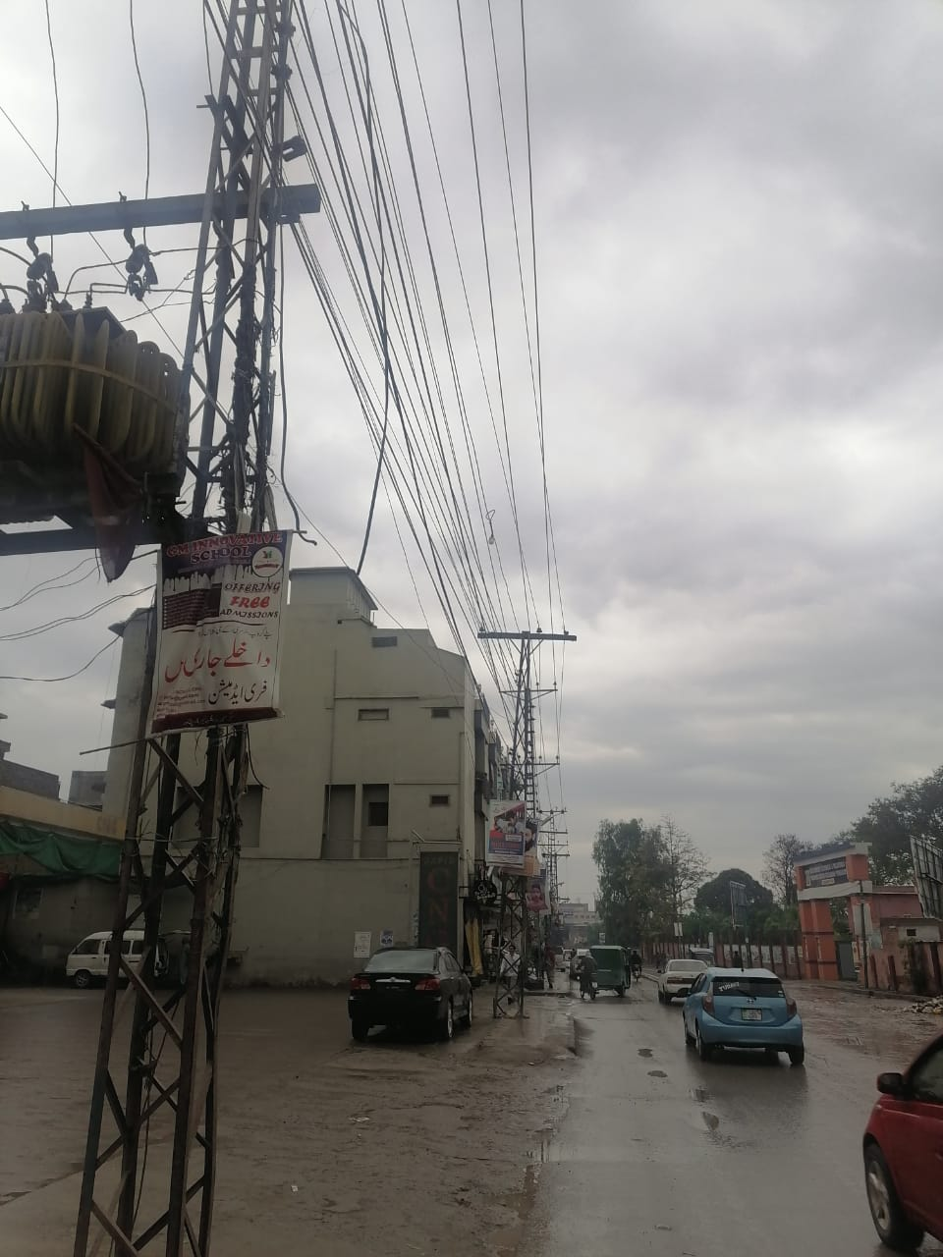

- Division: City Rural
S/Division: Nishtar abad
Feeder: Nishtar abad 2
Nishterabad also spells as Nishtarabad is a residential neighborhood in Peshawar city of Khyber Pakhtunkhwa province of Pakistan. Its exact location falls in the area known as Lahori, comes under the Union Council # 14 and having its catchment population 14175. This Feeder is in the urban area of the Peshawar city emanating from the city Grid Station. Total No of Consumers on the Feeder are 1028. The area mainly consists of Residential and commercial set ups with streets. The Major professions of the peoples are local small level business, shop keepers, Government and private employment, daily wagers (Masons, carpenters, black smith, cobblers). The law-and-order situation in the Right of Way of the feeder is Normal (No such civil unrest activities reported).

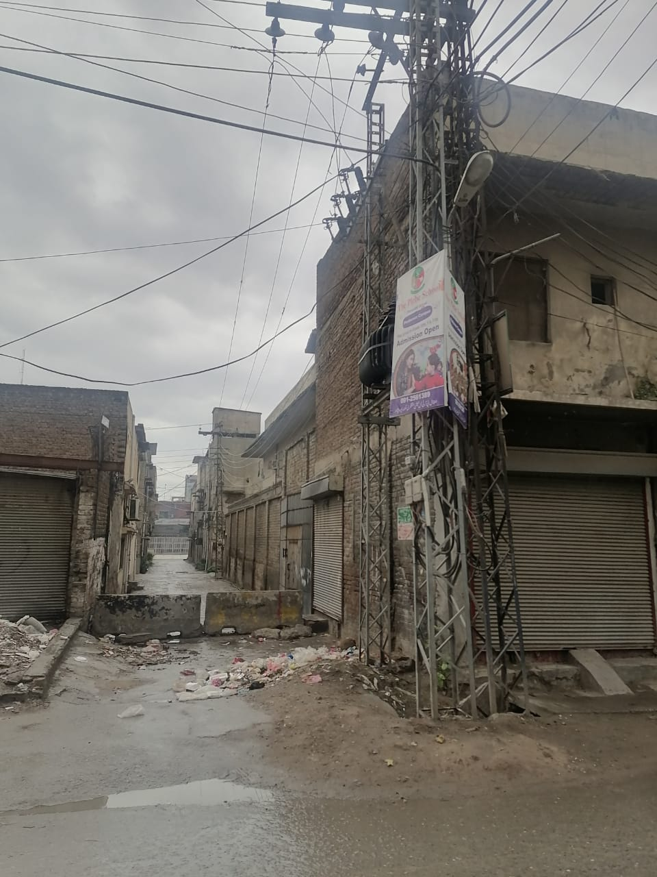

- Division: City Rural
S/Division: Faqir Abad
Feeder: Zaryab
Faqeerabad also spelled as Faqirabad, is a neighbourhood of Peshawar, Khyber Pakhtunkhwa, Pakistan. Hashtnagri is located to the south while Charsadda Road is located to the west, all the way up to the northern end of Faqeerabad. Faqeerabad is part of Pakistan National Assembly seat NA-31 (Peshawar-V) while for KP Provincial Assembly it is part of PF-1 (Peshawar-1)This Feeder is in the urban area of the Peshawar city emanating from the 132 KV City Grid Station. Total No of Consumers on the Feeder are 4393. The area mainly consists of Residential and commercial set ups with streets. The Major professions of the peoples are Rikshaw show rooms, Private tuition centers, local small level business, shop keepers, Government and private employment, daily wagers(Masons, carpenters, black smith, cobblers). The law and order situation in the Right of Way of the feeder is Normal (No such civil unrest activities reported).

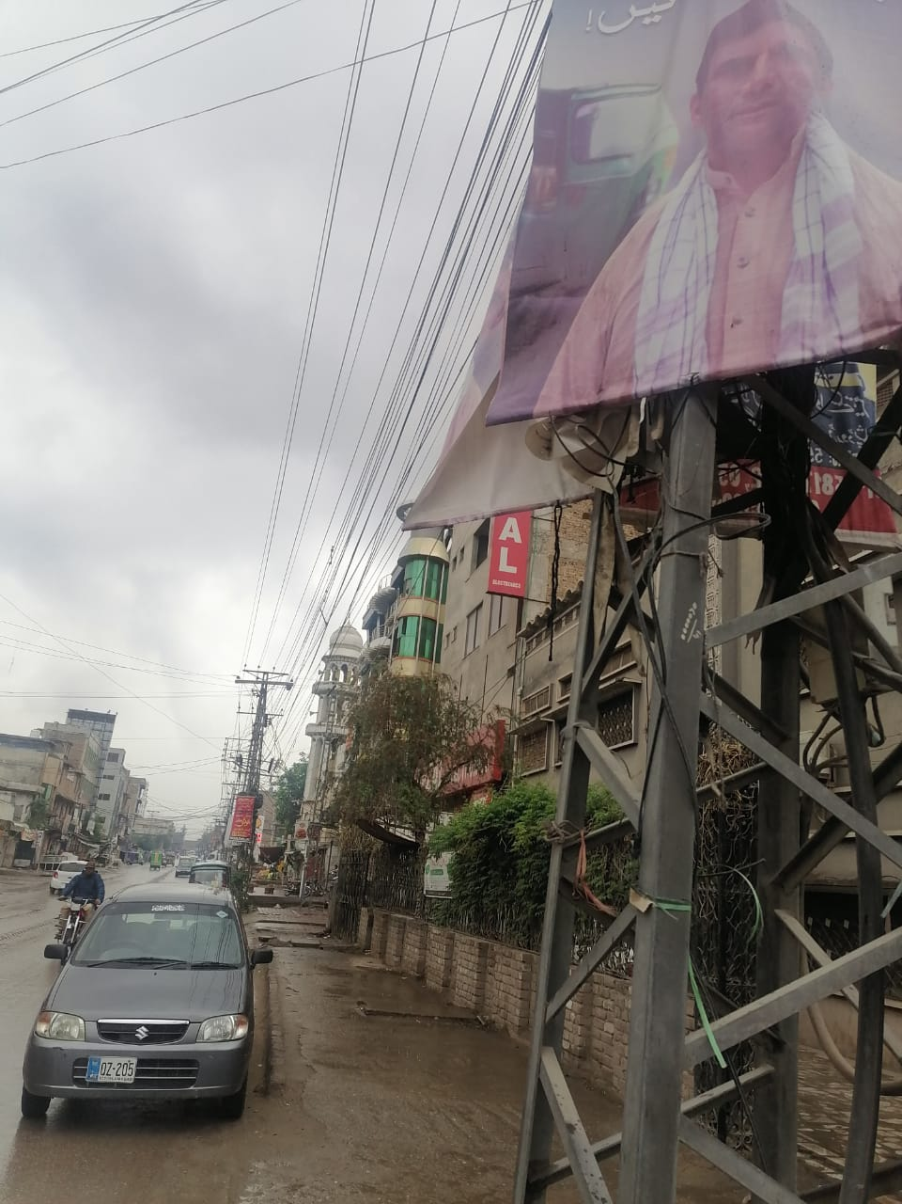

- Division: City Rural
S/Division: Rehman Baba
Feeder: Phando Baba
Phandu Baba area is situated nearby to Phando Bala and Choha Gujar 4-5 Kilometer from main ring road Peshawar. This Feeder is in the suburb’s city rural emanating from the 132 KV Rehman Baba Grid Station. Total No of Consumers on the Feeder are 1333. The area is mainly semi-rural Residential with streets. The Major professions of the peoples are local small scale business, shop keepers, Government and private employment, daily wagers(Masons, carpenters, black smith, cobblers), limited agriculture activities. The law-and-order situation in the Right of Way of the feeder is Normal (No such civil unrest activities reported).

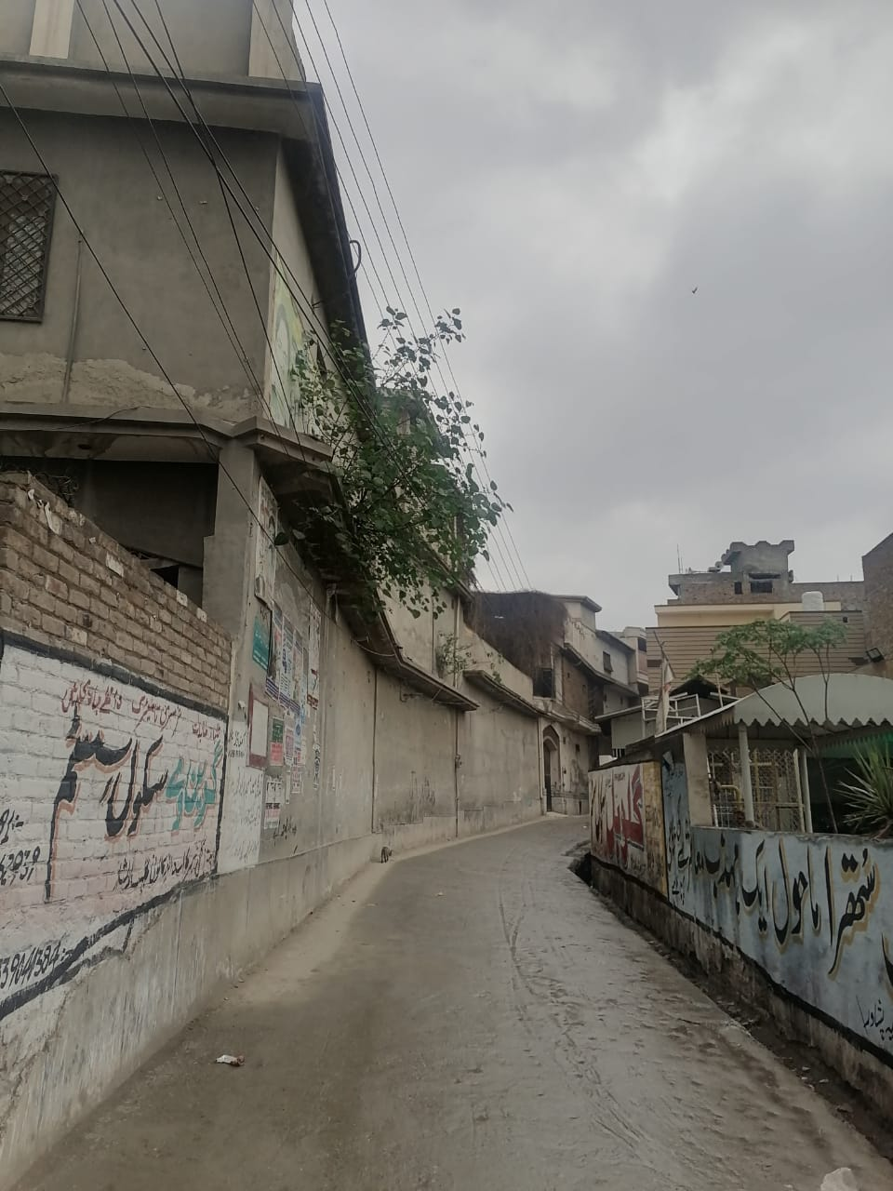

- Division: City Rural
S/Division: Rehman Baba
Feeder: Baghbanan
This Feeder is in the suburb’s city rural emanating from 132 KV Peshawar City. Total No of Consumers on the Feeder are 3687. The area is mainly semi-rural Residential with streets. The Major professions of the peoples are local small scale business, shop keepers, Government and private employment, daily wagers(Masons, carpenters, black smith, cobblers), limited agriculture activities. The law and order situation in the Right of Way of the feeder is Normal (No such civil unrest activities reported).

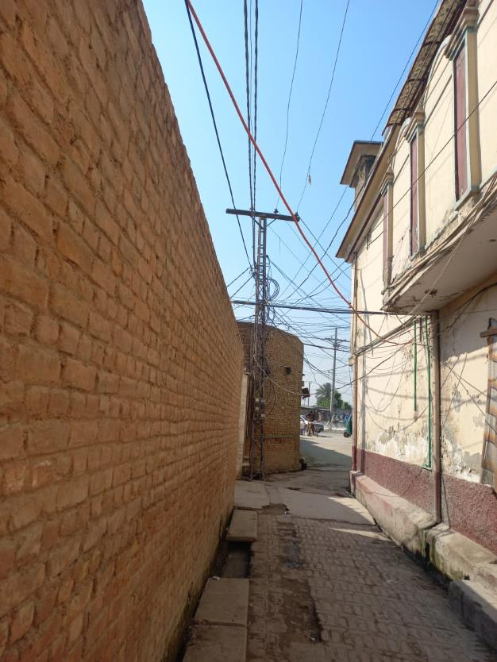

- Division: City Rural
S/Division: Lala
Feeder: Wadpaga 1
Wadpaga is located on main dalazak road a small village having semi rural characteristics.This Feeder is in the suburb’s city rural emanating from 132 KV Dalazak. Total No of Consumers on the Feeder are 4585. The area is mainly semi-rural Residential with streets. The major sources of livelihood are agriculture, daily wagers Government servants. The law-and-order situation in the Right of Way of the feeder is Normal (No such civil unrest activities reported).

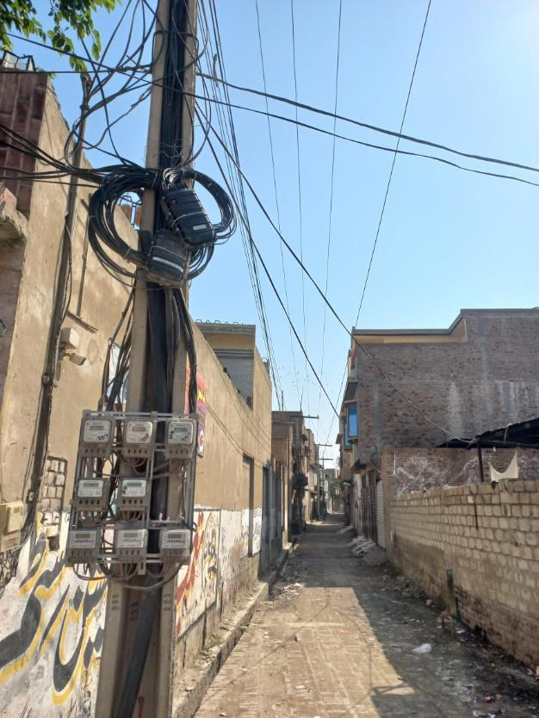

- Division: City Rural
S/Division: Lala
Feeder: Wadpaga 2
This Feeder is in the suburb’s city rural emanating from 132 KV Dalazak Grid station. Total No of Consumers on the Feeder are 3641. The area is mainly semi-rural Residential with streets. The major sources of livelihood are agriculture, daily wagers Government servants. The law-and-order situation in the Right of Way of the feeder is Normal (No such civil unrest activities reported).

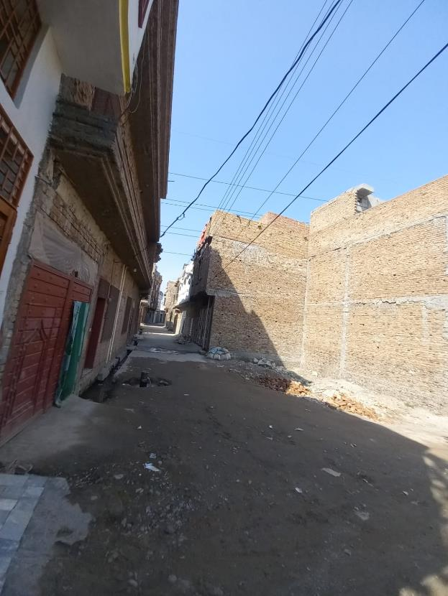

- Division: City Rural
S/Division: Lala
Feeder: Lala
This Feeder is in the suburb’s city rural emanating from 132 KV Grid station Peshawar city. Total No of Consumers on the Feeder are 2925. The area is mainly semi-rural Residential with streets. The major sources of livelihood are agriculture, daily wagers Government servants. The law and order situation in the Right of Way of the feeder is Normal (No such civil unrest activities reported).

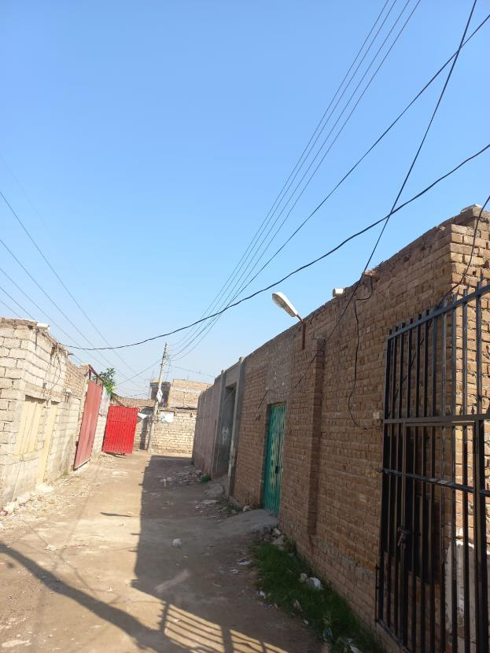

- Division: City Rural
S/Division: Sethi Town
Feeder: Pakha Ghulam
Sethi Town is a neighborhood Peshawar, Pakistan located in the east of historic Peshawar city. This Feeder is in the urban Peshawar emanating from 132 KV Grid Station Peshawar City. Total No of Consumers on the Feeder are 4693. The area is mainly semi-rural Residential with streets. The major sources of livelihood are agriculture, daily wagers Government servants. The law and order situation in the Right of Way of the feeder is Normal (No such civil unrest activities reported).

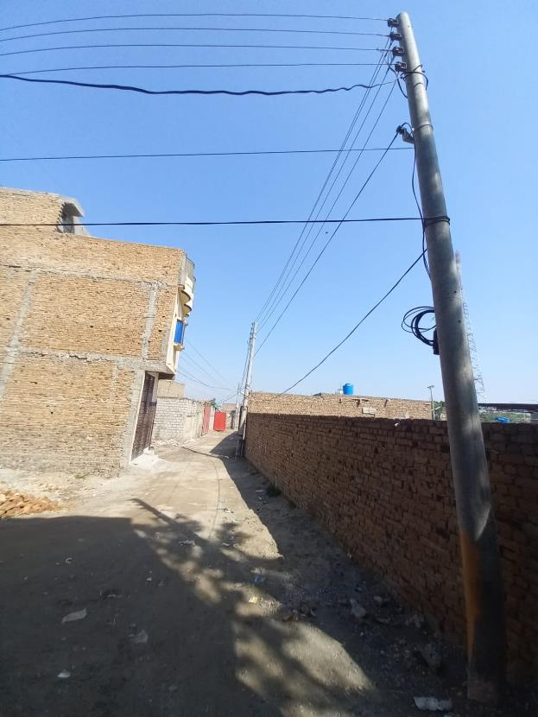

- Division: City Rural
S/Division: Sethi Town
Feeder: Gulabad
Sethi Town is a neighborhood in Haji Camp, Peshawar, Pakistan located in the east of historic Peshawar city near Haji Camp Bus Terminal of Peshawar. Total No of Consumers on the Feeder are 3855. The area is mainly urban Residential set ups with streets. The major sources of income include Groceries stores, Government servants and private employees, small scale business (hardware shops). The law-and-order situation in the Right of Way of the feeder is Normal (No such civil unrest activities reported).

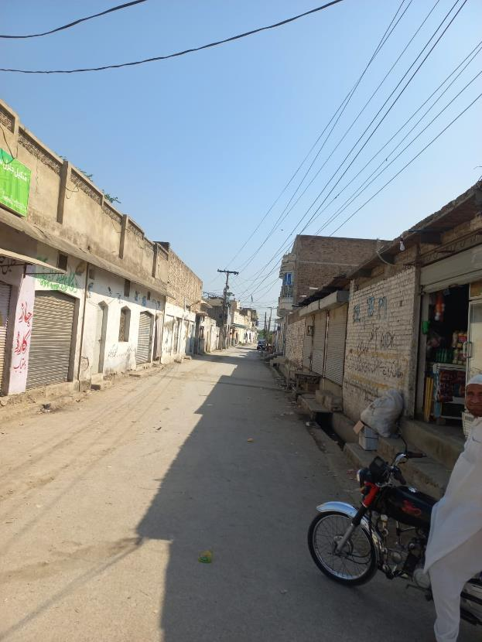

- Division: City Rural
S/Division: Sethi Town
Feeder: Sethi Town
Sethi Town is a neighborhood in Haji Camp, Peshawar, Pakistan located in the east of historic Peshawar city near Haji Camp Bus Terminal of Peshawar. Total No of Consumers on the Feeder are 5129. This feeder is emanating from 132 KV Grid station Peshawar city. The area is mainly comprised of urban Residential set ups with streets. The major sources of income includes Groceries stores, Government servants and private employees, small scale business (hardware shops). The law-and-order situation in the Right of Way of the feeder is Normal (No such civil unrest activities reported).

- Division: City Rural
S/Division: Sethi Town
Feeder: Sar biland pura
The Sarbiland pura is located on the main ring road Peshawar near to Sethi town the Feeder is emanating from 132 KV Shahi Bagh Grid Station. Total No of Consumers on the Feeder are 2702. The area is mainly comprised of urban Residential set ups with streets. The major sources of income includes Groceries stores, Government servants and private employees, small scale business (hardware shops). The law-and-order situation in the Right of Way of the feeder is Normal (No such civil unrest activities reported).

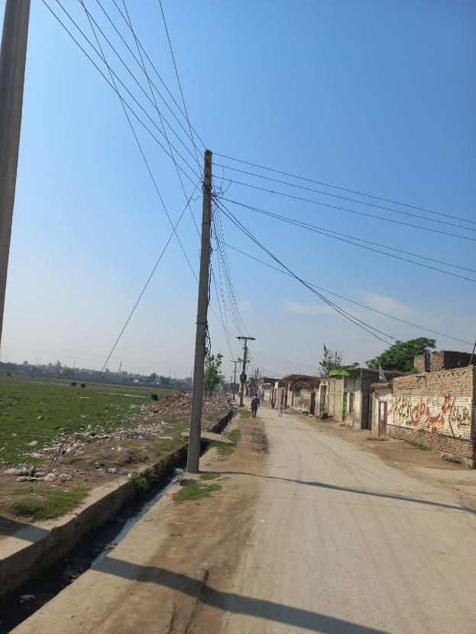

- Division: City Rural
S/Division: Sethi Town
Feeder: Dalazak
Dalazak is semi-rural area located about 5-6 Kilometer from main ring road. The feeder is emanating from 132 KV Shai bagh Grid station. Total No of Consumers on the Feeder are 5191. The area is mainly comprised of urban Residential and commercial set ups with streets. The major sources of income of the peoples includes agriculture, Groceries stores, Government servants and private employees, small scale business ((hardware shops, cement shop, wedding halls, private schools, hardware shops). The law-and-order situation in the Right of Way of the feeder is Normal (No such civil unrest activities reported).

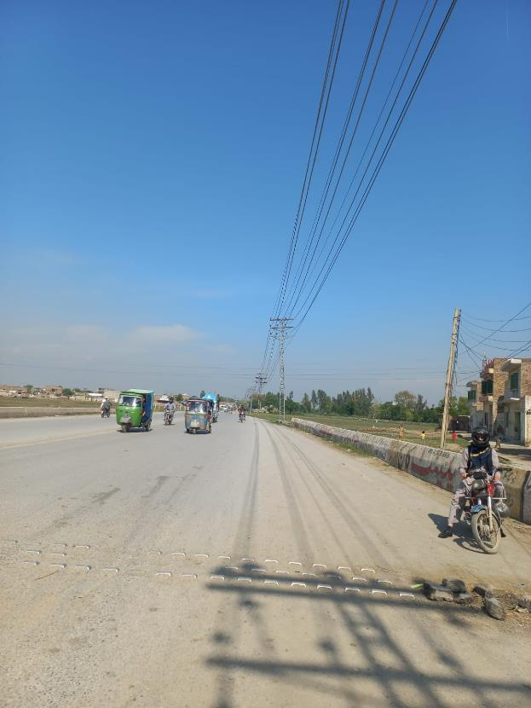

- Division: City Rural
S/Division: Rashid Garhi
Feeder: Rashid Garhi
Total No of Consumers on the Feeder are 5533. The area is mainly comprised of urban Residential and commercial set ups with streets. The major income generating sources are local business, shop keeping, tailor shops, shoes shop, cloth houses, groceries shops, Government and private employees (associated with pharma, sales men, real estates, petrol pumps, warehouses, private hospitals NGOs). The law-and-order situation in the Right of Way of the feeder is Normal (No such civil unrest activities reported).

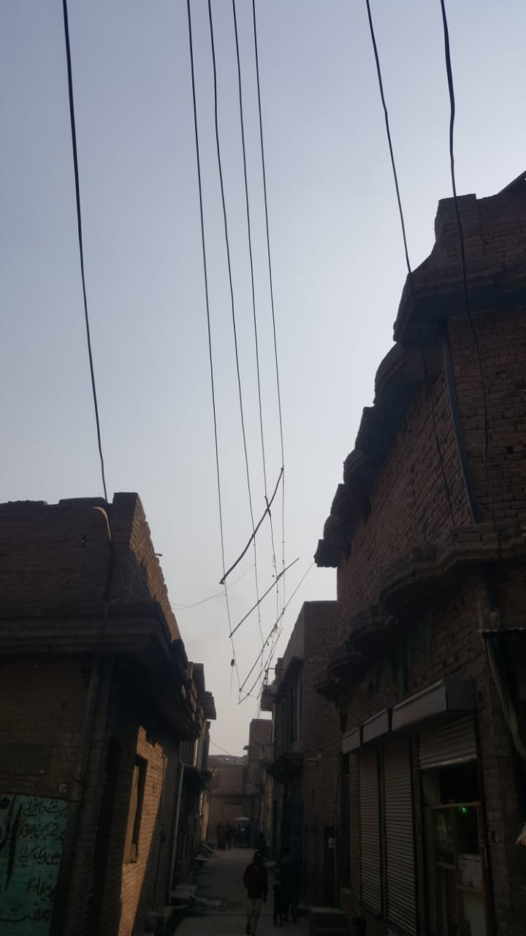

- Division: City Rural
S/Division: Phando
Feeder: Chairman Daftar
Total No of Consumers on the Feeder are 3956. The area is mainly comprised of urban Residential and commercial set ups with streets. The major income generating sources are local business, shop keeping, tailor shops, shoes shop, cloth houses, groceries shops, Government and private employees (associated with pharma, sales men, real estates, petrol pumps, warehouses, private hospitals NGOs). The law-and-order situation in the Right of Way of the feeder is Normal (No such civil unrest activities reported).

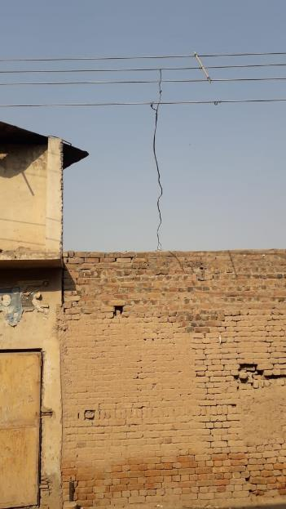

- Division: Cantt
S/Division: University-I
Feeder: Malkandher
Total number of consumers on the feeder are 4458. The area is mainly Semi rural residential set ups. The major income generating sources are local business, shop keeping, tailor shops, shoes shop, cloth houses, groceries shops, Government and private employees (associated with pharma, sales men, real estates, petrol pumps, warehouses, private hospitals NGOs. The law and order situation is Normal (No such civil unrest activities reported )
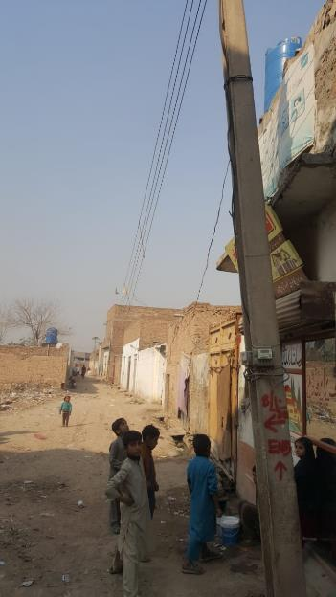

- S/Division: University-II
Feeder Name: G.abad
The total number of consumers on the feeder are 4497. The area mainly consists of urban residential set ups. The major income generating sources are local business, shop keeping, tailor shops, shoes shop, cloth houses, groceries shops, Government and private employees (associated with pharma, sales men, real estates, petrol pumps, warehouses, private hospitals NGOs). The law and order situation in area is Normal (No such civil unrest activities reported )

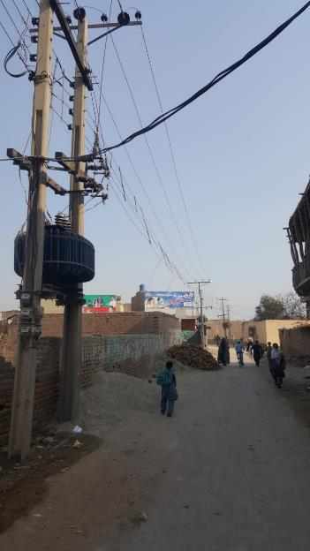

- S/Division:University-II
Feeder: Rahatabad
The total number of consumers are 2673. The area is comprised of urban residential set ups. The major income generating sources are local business, shop keeping, tailor shops, shoes shop, cloth houses, groceries shops, Government and private employees (associated with pharma, sales men, real estates, petrol pumps, warehouses, private hospitals NGOs). The law and order situation is Normal (No such civil unrest activities reported )

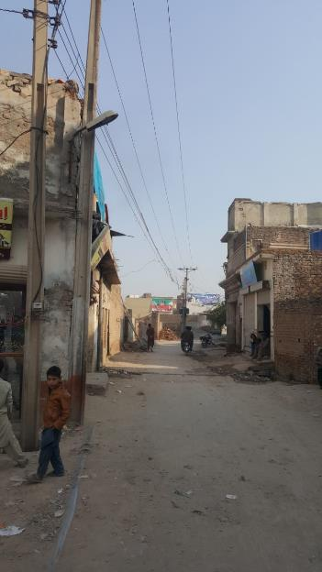
- S/Division:
Kohat road
Feeder Name: Kohat Road
The total number of consumers are 2734. The area is comprised of Urban residential set ups with commercial markets The major income generating sources are local business, shop keeping, tailor shops, shoes shop, cloth houses, groceries shops, Government and private employees (associated with pharma, sales men, real estates, petrol pumps, warehouses, private hospitals NGOs) . the law and order situation is Normal (No such civil unrest activities reported )
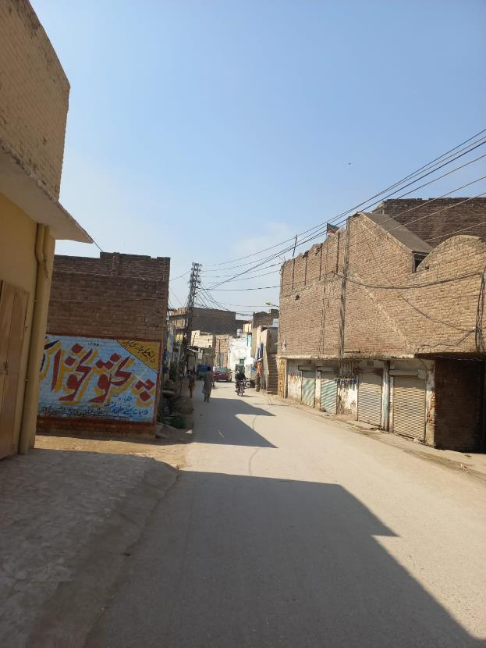

- S/Division: Kohat road
Feeder Name: New kohat road
The total number of consumers are 2935. The area is comprised of Semi-rural residential set ups with pockets of agri-land. The major occupations are Brick kiln, agriculture, pottery and transportation, Government + private employment. The law and order situation is Normal (No such civil unrest activities reported )

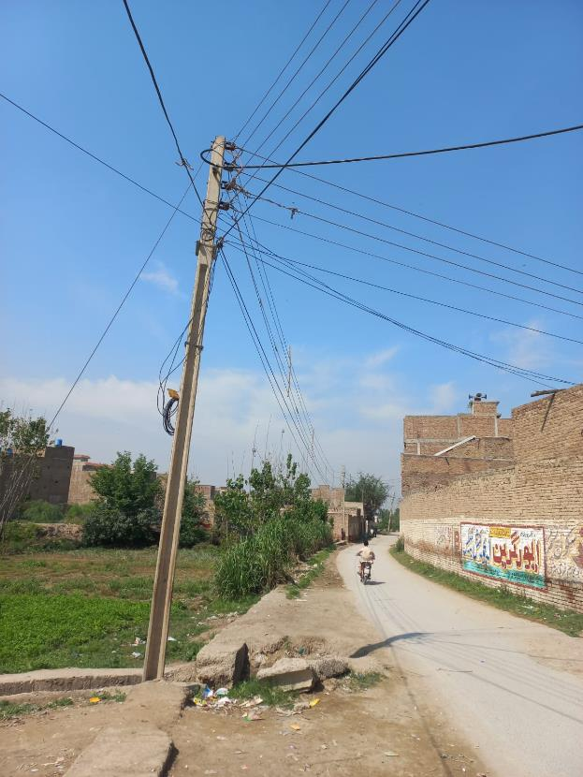
- Division: Charsadda
S/Division: Charsadda
Feeder: Charsadda-IV
The total number of consumers are 6049. The area is comprised of rural residential set ups with pockets of agri-land The major occupations are Government and Private employment and agriculture local traditional cloth industry hand and machine based(Famous Charsaddah khaddar) Charsaddah sweets (Famous Rajar sweets), Charsaddah Famous meat rice(Mota chawal) Charsaddah Famous Chappal. The law and order situation is Normal (No such civil unrest activities reported ).

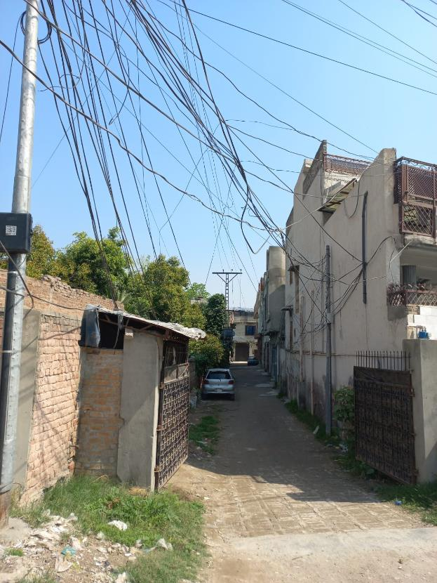
- S/Division: Charsadda
Feeder: Charsadda-1
The total number of consumers are 5203. The area is mainly rural and residential with pockets of agri-land. The major occupations are Government and Private employment and agriculture local traditional cloth industry hand and machine based(Famous Charsaddah khaddar) Charsaddah sweets (Famous Rajar sweets), Charsaddah Famous meat rice(Mota chawal) Charsaddah Famous chappal. The law and order situation is Normal (No such civil unrest activities reported )

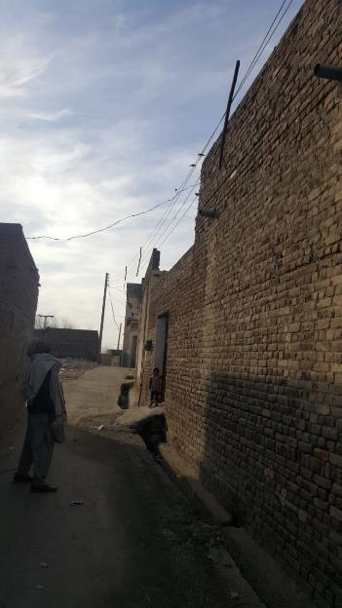

- S/Division: Charsadda
Feeder: Charsadda-3
The total number of consumers are 4177. The area is mainly rural and residential with pockets of agri-land. The major occupations are Government and Private employment and agriculture local traditional cloth industry hand and machine based(Famous Charsaddah khaddar) Charsaddah sweets (Famous Rajar sweets), Charsaddah Famous meat rice(Mota chawal) Charsaddah Famous Chappal. The lawa and order situation is Normal (No such civil unrest activities reported )

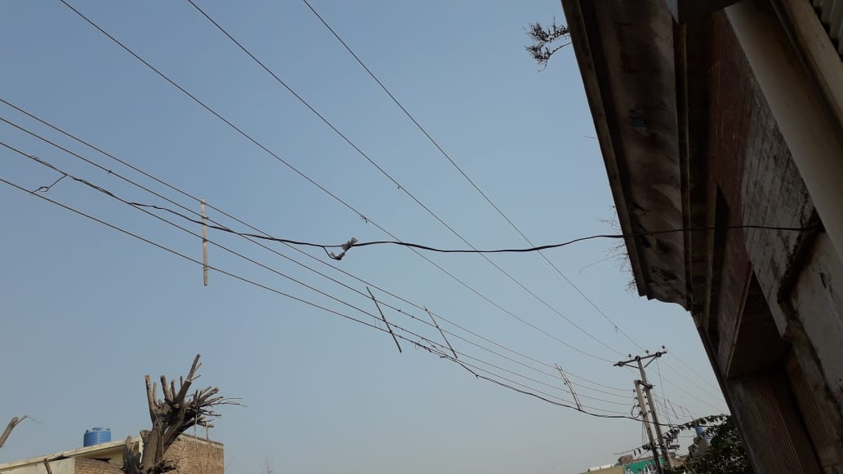

- S/Division: Sardheri
Feeder: Dargai
The total number of consumers are 4891.
The feeder area is mainly rural residential with pockets of agri-land. The major occupations are Government and Private employment and agriculture local traditional cloth industry hand and machine based(Famous Charsaddah khaddar) Charsaddah sweets (Famous Rajar sweets), Charsaddah Famous meat rice(Mota chawal) the law and order situation is Normal (No such civil unrest activities reported )

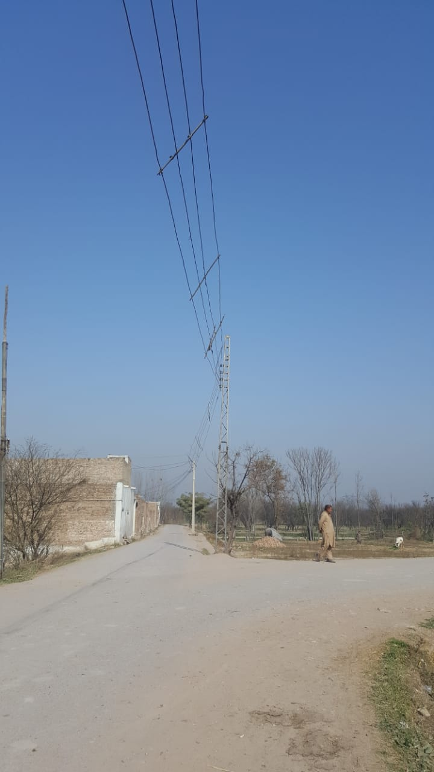

- S/Divion:Sardheri
Feeder: Sardheri
The total number of consumer are 5524.
The area is mainly rural and residential with pockets of agri-land.The major occupations are Government and Private employment and agriculture local traditional cloth industry hand and machine based(Famous Charsaddah khaddar) Charsaddah sweets (Famous Rajar sweets), Charsaddah Famous meat rice(Mota chawal) the law and order situation is Normal (No such civil unrest activities reported )

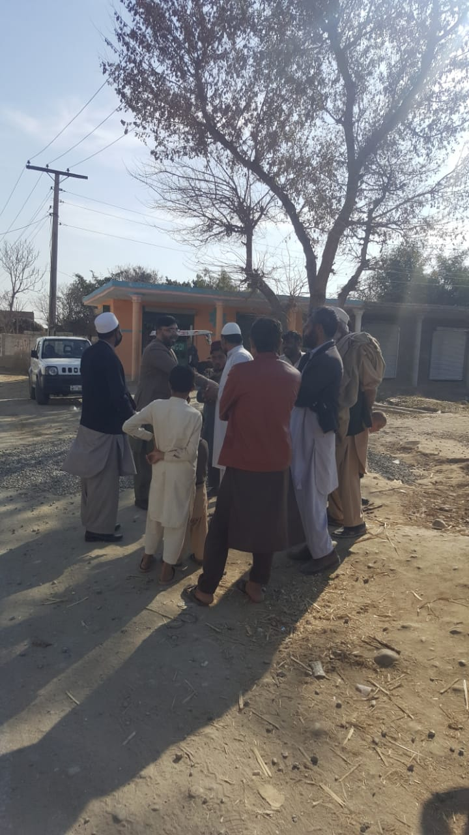
- S/Division:Utmanzai
Feeder: Rajjar . the total number of consumer are 5781. The area is mainly rural and residential with pockets of agri-land. The major occupations are Government and Private employment and agriculture local traditional cloth industry hand and machine based(Famous Charsaddah khaddar) Charsaddah sweets (Famous Rajar sweets), Charsaddah Famous meat rice(Mota chawal). The law and order situation is Normal (No such civil unrest activities reported )

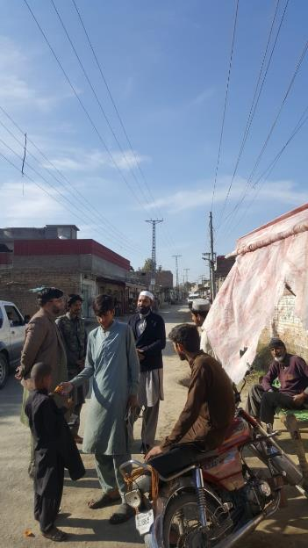

- S/Division :Nisatta (Rural)
Feeder: Prang. The total number of consumers are 4251. The area is mainly rural and residential with pockets of agri-land The major occupations are Government and Private employment and agriculture local traditional cloth industry hand and machine based(Famous Charsaddah khaddar) Charsaddah sweets (Famous Rajar sweets), Charsaddah Famous meat rice(Mota chawal). The law and order situation is Normal (No such civil unrest activities reported )
- S/Division:Shabqadar
Feeder: Tangi Barazai. The total number of consumers are 5276. The area is mainly Rural and residential .The major occupations are Government and Private employment and agriculture local traditional cloth industry hand and machine based(Famous Charsaddah khaddar) Charsaddah sweets (Famous Rajar sweets), Charsaddah Famous meat rice(Mota chawal). The law and order situation is Normal (No such civil unrest activities reported )

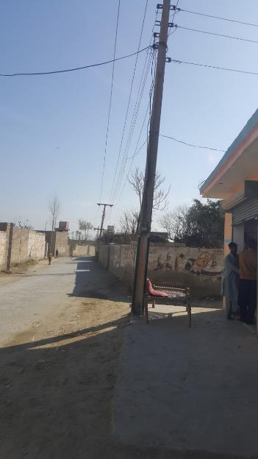
- S/Division:Tangi
Feeder Name: Tangi Nusratzai. The total number of consumer are 3955. The area is mainly rural and residential with pockets of agri-land The major occupations are Government and Private employment and agriculture, local traditional cloth industry hand and machine based(Famous Charsaddah khaddar) Charsaddah sweets (Famous Rajar sweets), Charsaddah Famous meat rice(Mota chawal). The law and order situation is Normal (No such civil unrest activities reported).
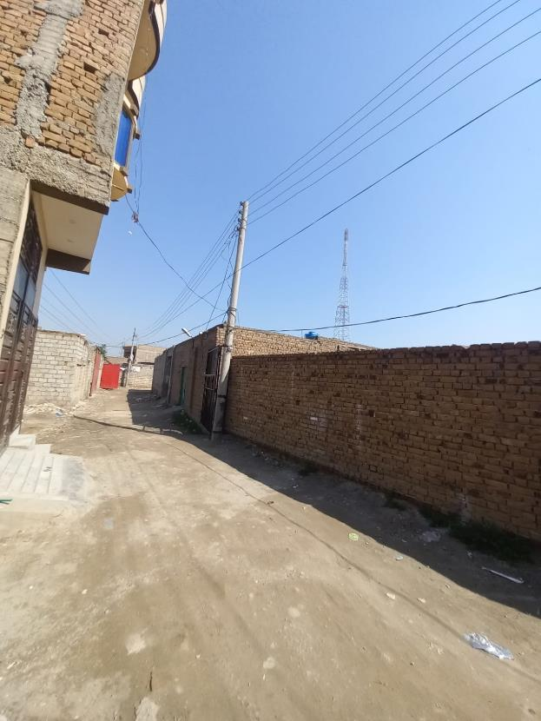
- S/Division:Matta
Feeder: Katozai-2. The total number of consumer are 1529. The area is mainly rural and residential set ups with pockets of agri-land. The major income sources are agriculture (Cash Crops are sugar cane, strawberry, tomatoes, Poplar trade, sweet melon, jaggery, the law and order situation is Normal (No such civil unrest activities reported )

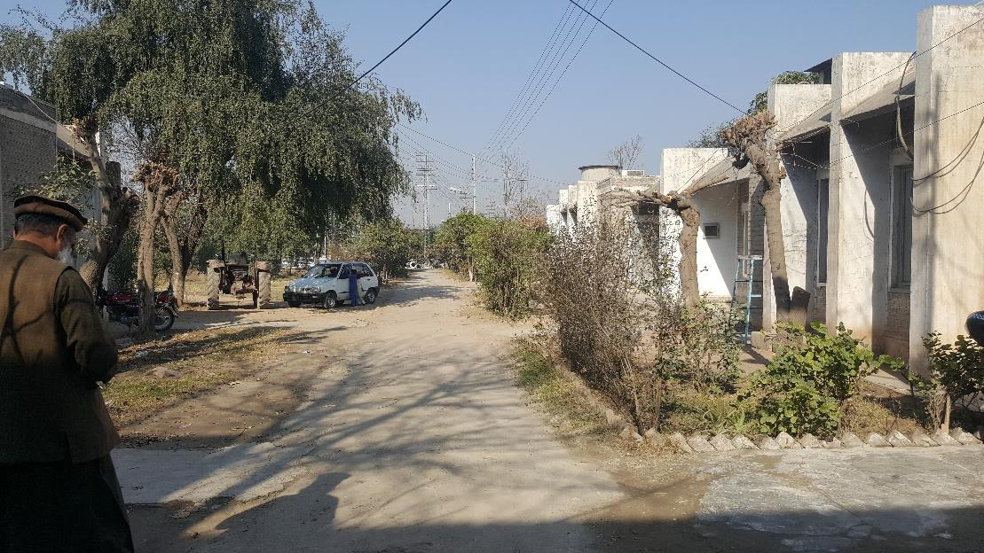
- S/Division: Matta
Feeder: Moran Koruna.
The total number of consumer are1759. The area is mainly rural and residential with pockets of agri-land The major livelihood sources are Poplar trade(Match industry), agriculture, Government and private employees, honey bee keeping, Fish huts, poultry forms, the law and order situation is Normal (No such civil unrest activities reported )

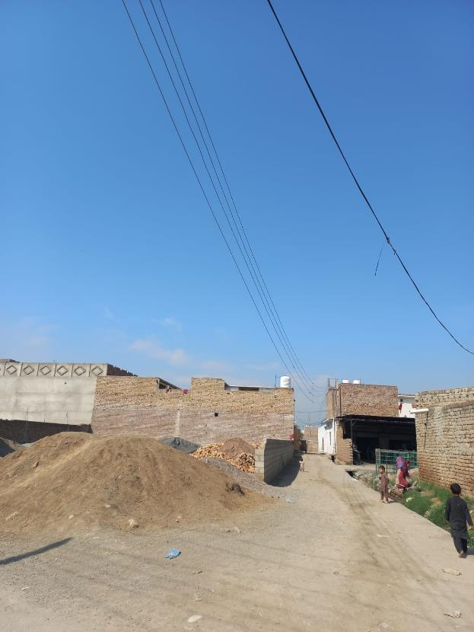

- S/Division: Doaba
Feeder: Pir Qilla. The total number of consumers are 4035. The area is mainly rural and residential with pockets of agri-land. The major livelihood sources are Poplar trade(Match industry), agriculture, Government and private employees, honey bee keeping, Fish huts, poultry forms,. The law and order situation is Normal (No such civil unrest activities reported )
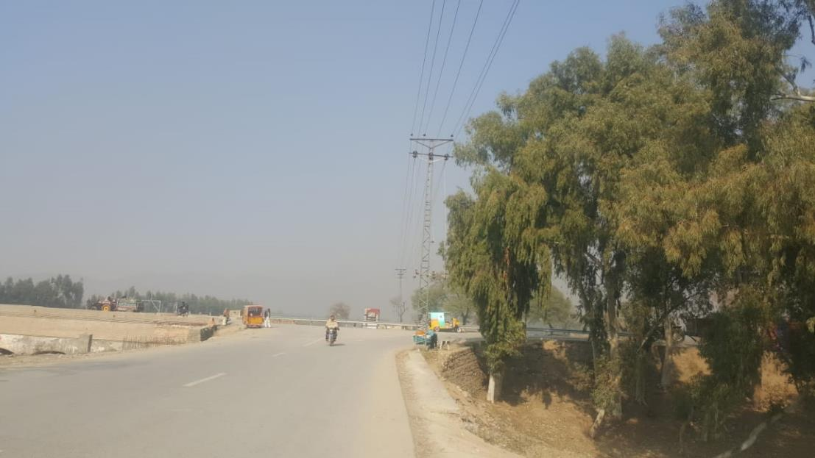

- S/Division: Shabqadar
Feeder: Shabqadar Fort. The total number of consumers are 3206. The area is mainly rural and residential with pockets of agri-land The major livelihood sources are Poplar trade(Match industry), agriculture, Government and private employees, honey bee keeping, Fish huts, poultry forms, mangoes export quality, block factories, Marble factories, Plastic PVC pipe industry, small scale local business, commercial markets.. the law and order situation is Normal (No such civil unrest activities reported )

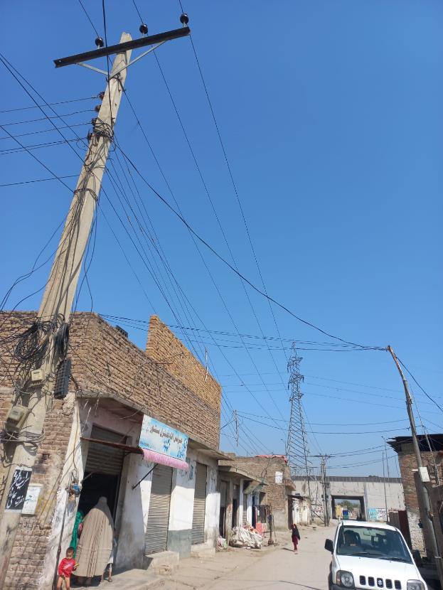

- S/Division: Rural Warsak-I
Feeder: Mathra-I. The total number of consumers are 2687. The area is mainly rural and residential with pockets of agri-land The major sources of income are real estate, marble industry, agriculture, private school, private health facilities, government and private employment, local transportation . the law and order situation is Normal (No such civil unrest activities reported )

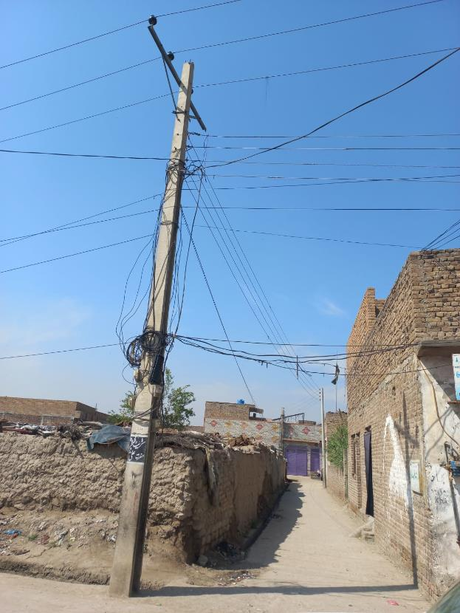
- S/Division: Daud zai
Feeder: Nishat-I. the total number of consumers are 4609. The area is mainly rural and residential with pockets of agri-land. The major sources of income are real estate, agriculture, private school, Fish huts, government and private employment, local transportation, the law and order situation is Normal (No such civil unrest activities reported )
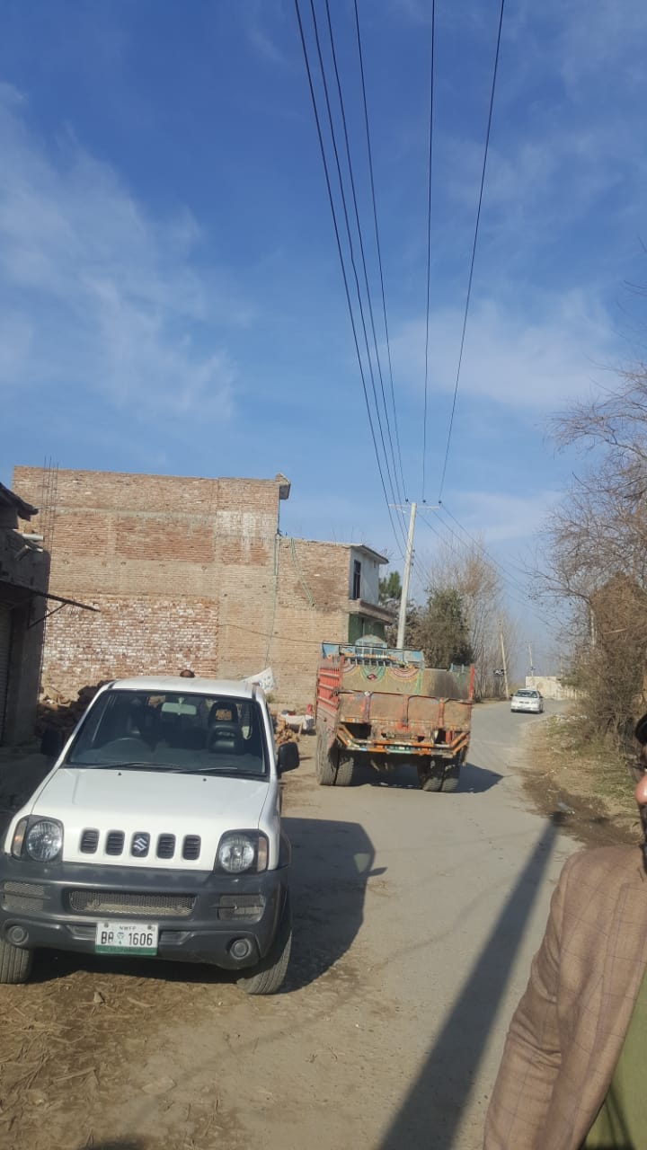
- S/Division: Daud zai
Feeder: Nishat-II.
The total number of consumers are 2315. The area is mainly rural residential set ups with pockets of agri-land. The major sources of income are real estate, agriculture, private school, Fish huts, government and private employment, local transportation, the law and order situation is Normal (No such civil unrest activities reported ) the law and order situation in the area is Normal (No such civil unrest activities reported )

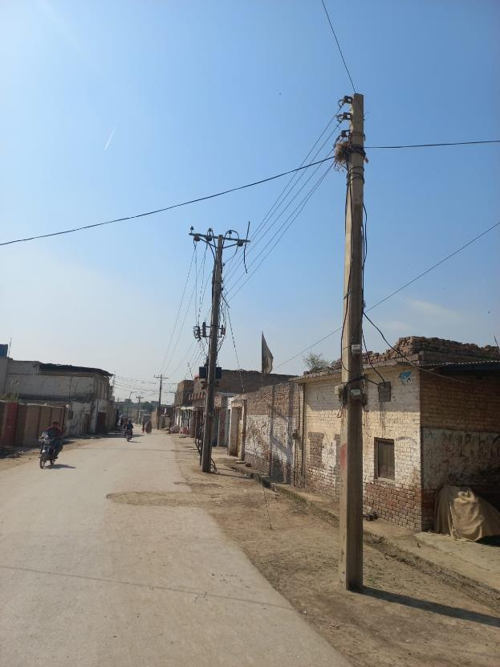
- S/Division: Gulbela
Feeder: Daud zai-I. The total number of consumers are 6070. The area is mainly rural residential set ups with pockets of agri-land. The major sources of income are real estate, agriculture, private school, Fish huts, government and private employment, local transportation, the law and order situation is Normal (No such civil unrest activities reported )
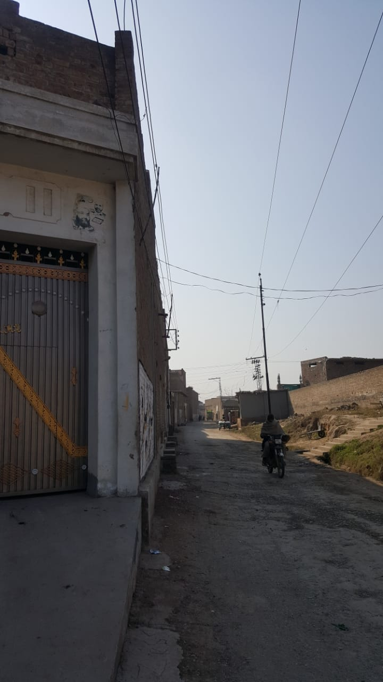
- S/Division: Gulbela
Feeder: Khazana-2. The total number of consumers are 5755. The area is mainly rural residential set ups with pockets of agri-land. The major sources of income are real estate, agriculture, private school, Fish huts, government and private employment, local transportation, the law and order situation is Normal (No such civil unrest activities reported )
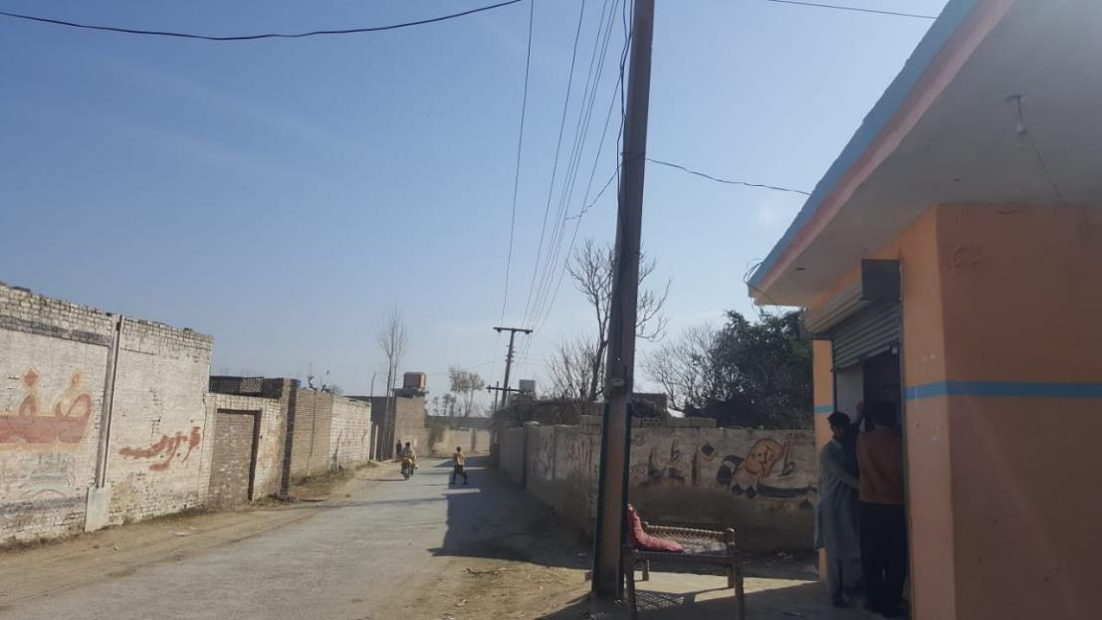
- S/Division: Gulbela
Feeder: Khazana. The total number of consumers are 3428. The area is mainly rural residential set ups with pockets of agri-land. The major sources of income are real estate, agriculture, private school, Fish huts, government and private employment, local transportation, Famous Khazana sugar mill, local woof furniture industry, commercial markets. the law and order situation is Normal (No such civil unrest activities reported )
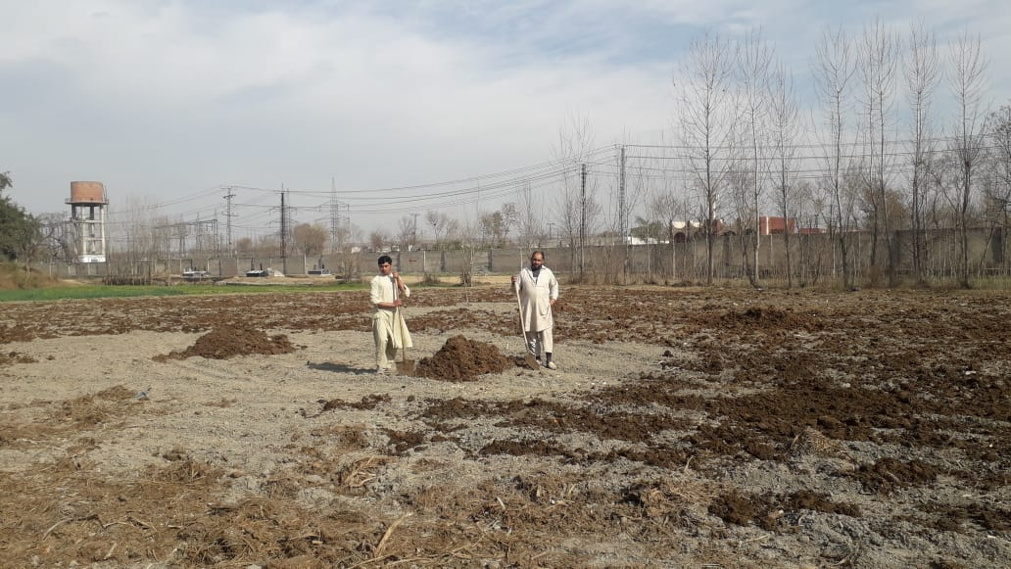
- S/Division: Warsak-II
Feeder: Kaniza. The total number of consumers are 2195. The area is mainly rural residential set ups with pockets of agri-land. The major livelihood sources are agriculture, Government employment, local shop keepers, the law and order situation is Normal (No such civil unrest activities reported )
- S/Division: Warsak-II
Feeder: Regi The total number of consumers are 1579. The area is mainly rural residential set ups with pockets of agri-land The major livelihood sources are agriculture, Government and private employment, local shop keepers, the law and order situation is Normal (No such civil unrest activities reported )
- S/Division: Warsak-II
Feeder: Pajagi The total number of consumers are 4983. The area is mainly rural residential set ups with pockets of agri-land The major livelihood sources are agriculture, Government and private employment, local shop keepers, the law and order situation is Normal (No such civil unrest activities reported )
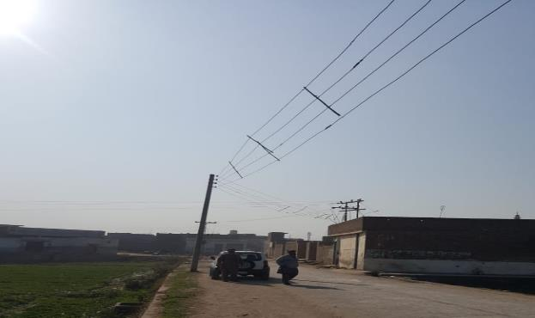
- S/Division: Naguman
Feeder: Daudzai-II. The total number of consumers are 4866. The area is mainly rural residential set ups with pockets of agri-land. The major livelihood sources are agriculture, Government and private employment, local shop keepers, the law and order situation is Normal (No such civil unrest activities reported )
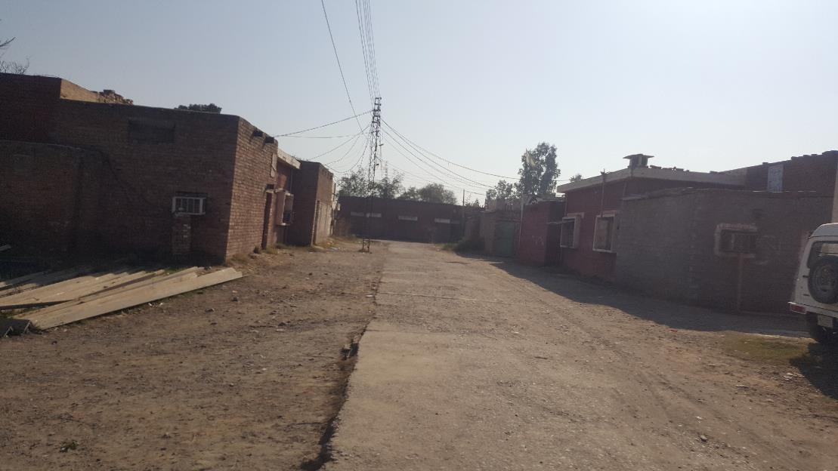
- Division: Khyber
S/Division: Bahadar
Feeder: Sheikhan. The total number of consumers are 1666. The area is mainly rural residential set ups with pockets of agri-land The major livelihood sources are agriculture, Government and private employment, local shop keepers, the law and order situation is Normal (No such civil unrest activities reported )
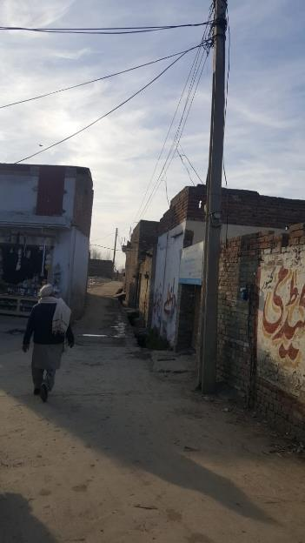
- S/Division: NSR City No. 2
Feeder: Pabbi-III P.S.O.
The total number of consumers are 4395. The area is mainly rural residential set ups with pockets of agri-land The major livelihood sources are agriculture, Government and private employment, local shop keepers, nurseries forms, azakhel botanical garden, commercial market, private school and colleges, fuel wood business, Cherat cement factory , real estate business. The law and order situation is Normal (No such civil unrest activities reported )

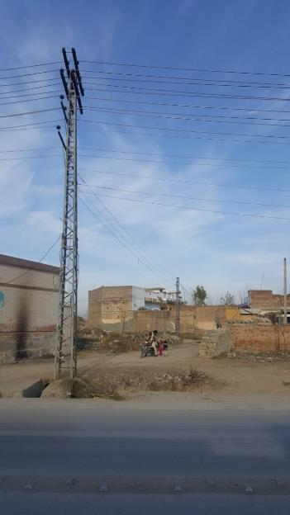
- S/Division: Pabbi-III
Feeder: Taru Jabba. The total number of consumers are 4031. The area is mainly rural residential set ups with pockets of agri-land The major income sources are agriculture, Taru main oil depot, Taru famous chappli kabab eatery, Fish huts, heavy vehicle workshops, Government and private employment, NIFA (Nuclear institute of Food and agriculture).The law and order situation is Normal (No such civil unrest activities reported )
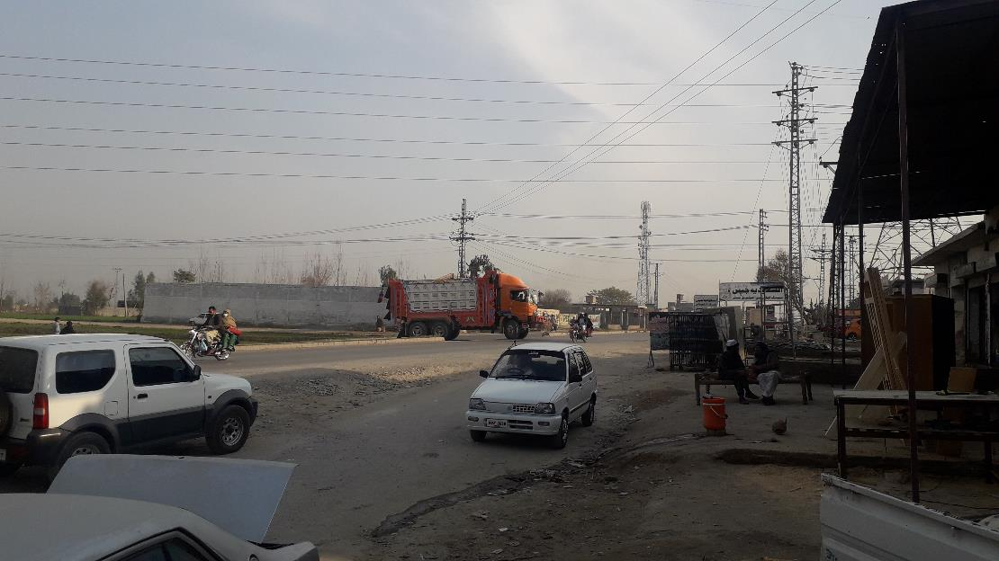
- S/Division: Pabbi-III
Feeder: Akbar Pura. The total number of consumers are 5309. The area is mainly rural residential set ups with pockets of agri-land. The major income sources are agriculture, Fish huts, commercial markets, Government and private employment. The law and order situation is Normal (No such civil unrest activities reported )
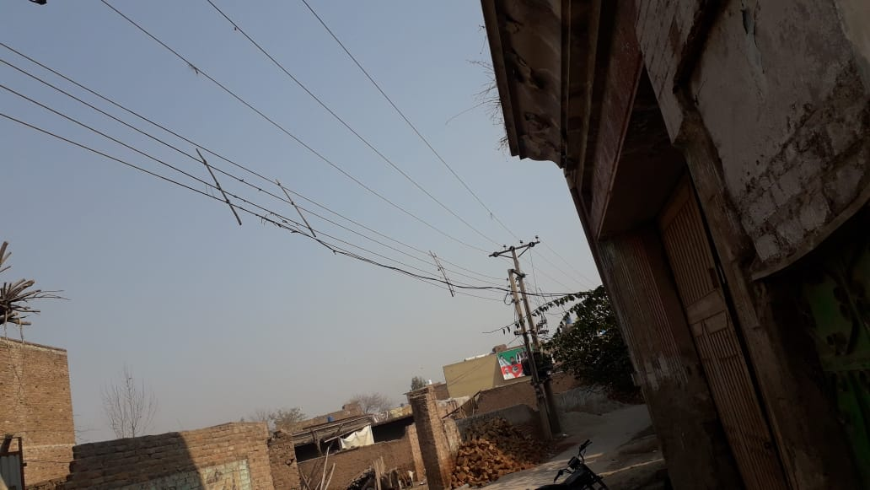

- S/Division: Pabbi-III
Feeder: Tarnab. The total number of consumers are 4474. The area is mainly rural residential set ups with pockets of agri-land. The major income sources are agriculture, Fish huts, Government and private employment,
Plants Nurseries forms. the law and order situation is Normal (No such civil unrest activities reported ).
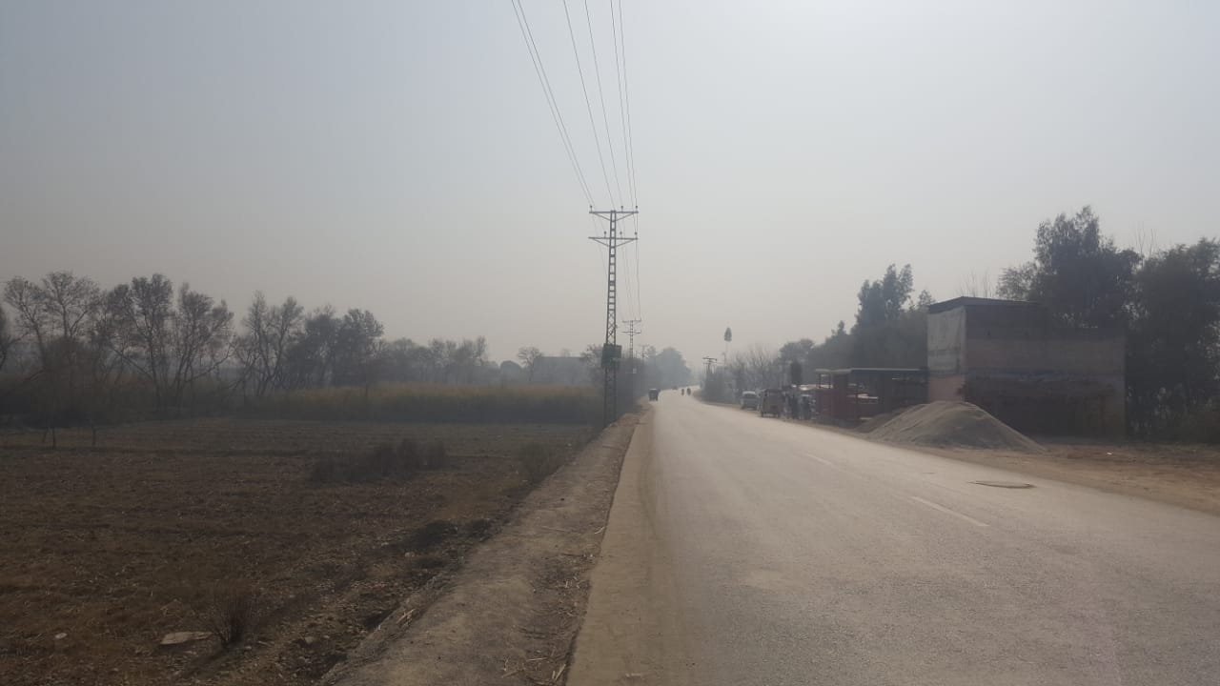

- S/Division: Pabbi-III
Feeder: Scarp- I. The total number of consumers are 4285. The area is mainly rural residential set ups with pockets of agri-land The major income sources are agriculture, Fish huts, Government and private employment,
Plants Nurseries forms. the law and order situation is Normal (No such civil unrest activities reported )

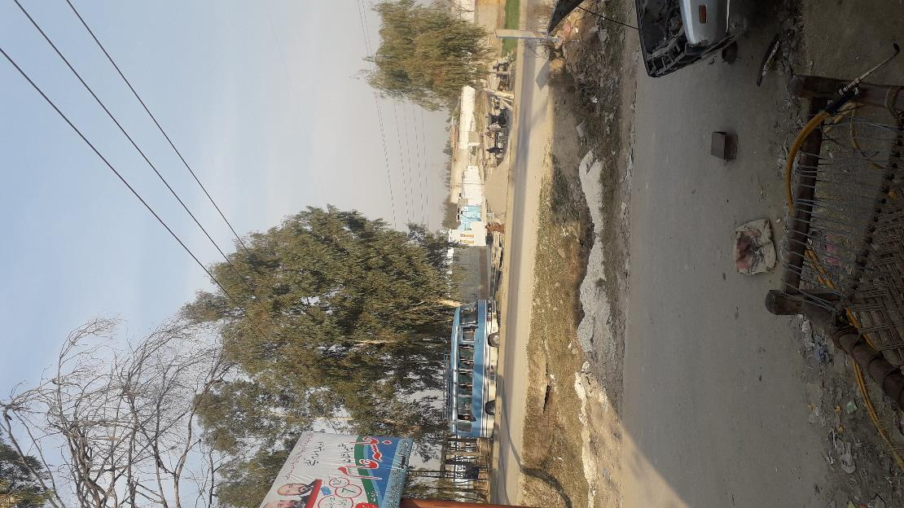

- S/Division: Kotal Town
Feeder: Eid Gah Kohat . The total number of consumers are 1158. The area is mainly rural residential. The major sources of livelihood are transportation, oversees Pakistani(Gulf countries), Government and Private employment, local small business, Poultry and local breeds of cattle are also good source of income for the people of Kohat. The law and order situation is Normal (No such civil unrest activities reported )

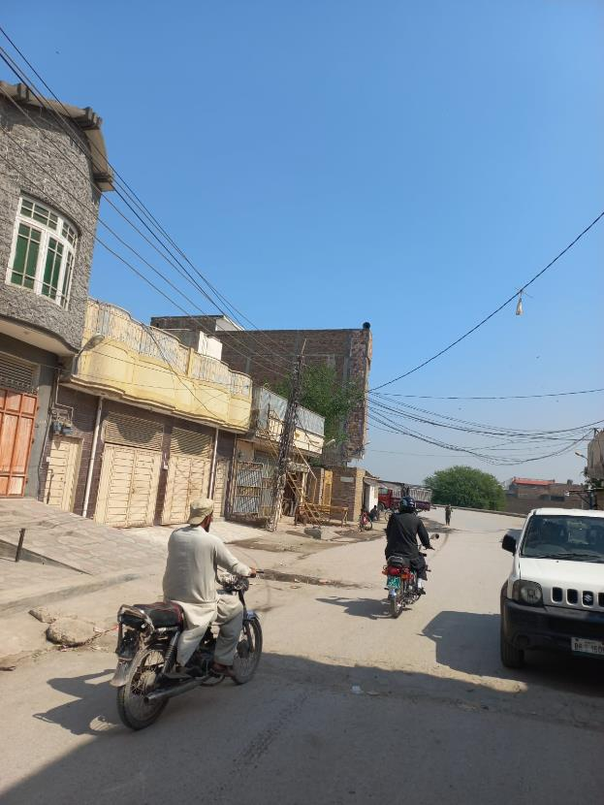
- S/Division: Kohat Rural
Feeder: Rural Hangu Road. The total number of consumers are 4220. The area is mainly comprised of Rural mountainous residential set up with barren land. The major sources of livelihood are transportation, oversees Pakistani(Gulf countries), Government and Private employment, local small business, Poultry and local breeds of cattle are also good source of income for the people of Kohat .The law and order situation is Normal (No such civil unrest activities reported )
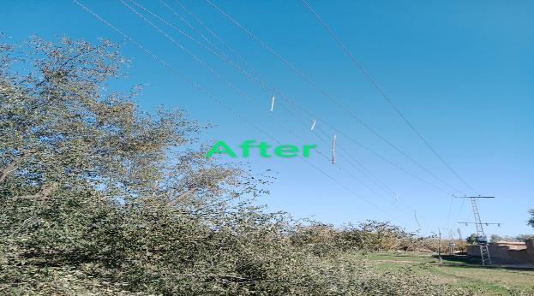
- S/Division: Rural
Feeder: Alizai-1. The total number of consumers are 3431. The area is mainly comprised of Located on main road non productive rain fed fields few pockets of Guava orchards. The major sources of livelihood are transportation, oversees Pakistani(Gulf countries), Government and Private employment, local small business. Hortilture(Guava export quality), Poultry and local breeds of cattle are also good source of income for the people of Kohat .The law and order situation is Normal (No such civil unrest activities reported )
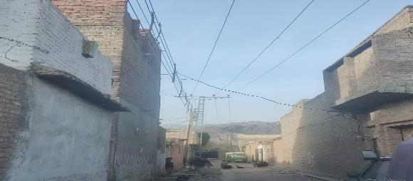
- S/Division: Rural
Feeder: Alizai-2. The total number of consumers are 2613. The area is mainly comprised of Located on main road non productive rain fed fields few pockets of Guava orchardsThe major sources of livelihood are transportation, oversees Pakistani(Gulf countries), Government and Private employment, local small business. Hortilture(Guava export quality), Poultry and local breeds of cattle are also good source of income for the people of Kohat .The law and order situation is Normal (No such civil unrest activities reported )

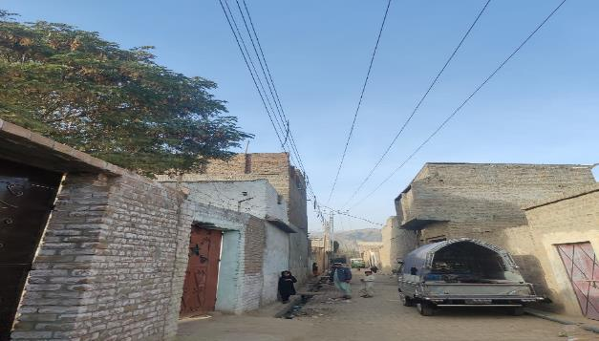
- S/Division: Rural
Feeder: Barh The total number of consumers are 3705. The area is mainly comprised of Village type residential set up mostly barren land The major sources of livelihood are transportation, oversees Pakistani(Gulf countries), Government and Private employment, local small business, Poultry and local breeds of cattle are also good source of income for the people of Kohat The law and order situation is Normal (No such civil unrest activities reported )
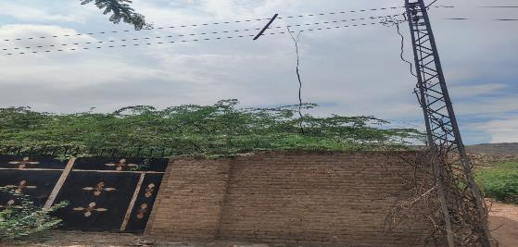
- S/Division: Rural
Feeder: O.T.S The total number of consumers are 4071. The area is mainly comprised of Urban city type area with streets. The major sources of livelihood are transportation, oversees Pakistani(Gulf countries), Government and Private employment, local small business, Poultry and local breeds of cattle are also good source of income for the people of Kohat. The law and order situation is Normal (No such civil unrest activities reported )
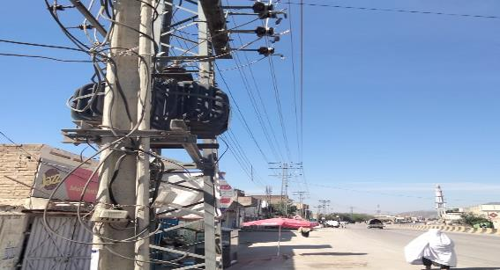
- S/Division: Rural
Feeder: Gamgol Sharif. The total number of consumers are 1900. The area is mainly comprised of Urban + rural set ups with pocket agri-land. The major sources of livelihood are transportation, oversees Pakistani(Gulf countries), Government and Private employment, local small business. Hortilture(Guava export quality), Poultry and local breeds of cattle are also good source of income for the people of Kohat .The law and order situation is Normal (No such civil unrest activities reported )
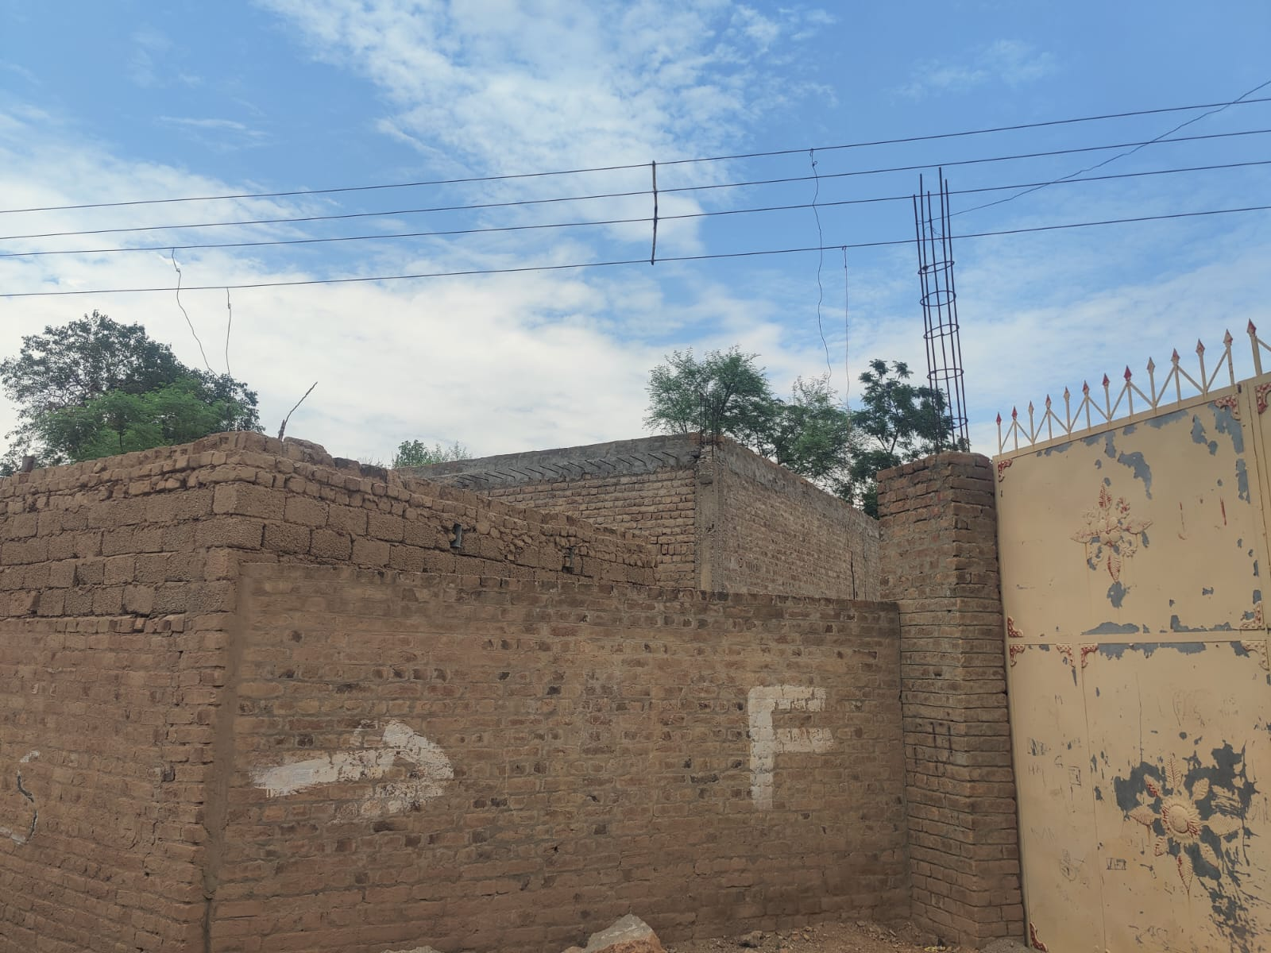
- S/Division: Kohat Urban-II
Feeder: City-4
The total number of consumers are 4493. The area is mainly comprised of Main city commercial + residential The major sources of livelihood are transportation, oversees Pakistani(Gulf countries), Government and Private employment, local small business, Poultry and local breeds of cattle are also good source of income for the people of Kohat. The law and order situation is Normal (No such civil unrest activities reported )
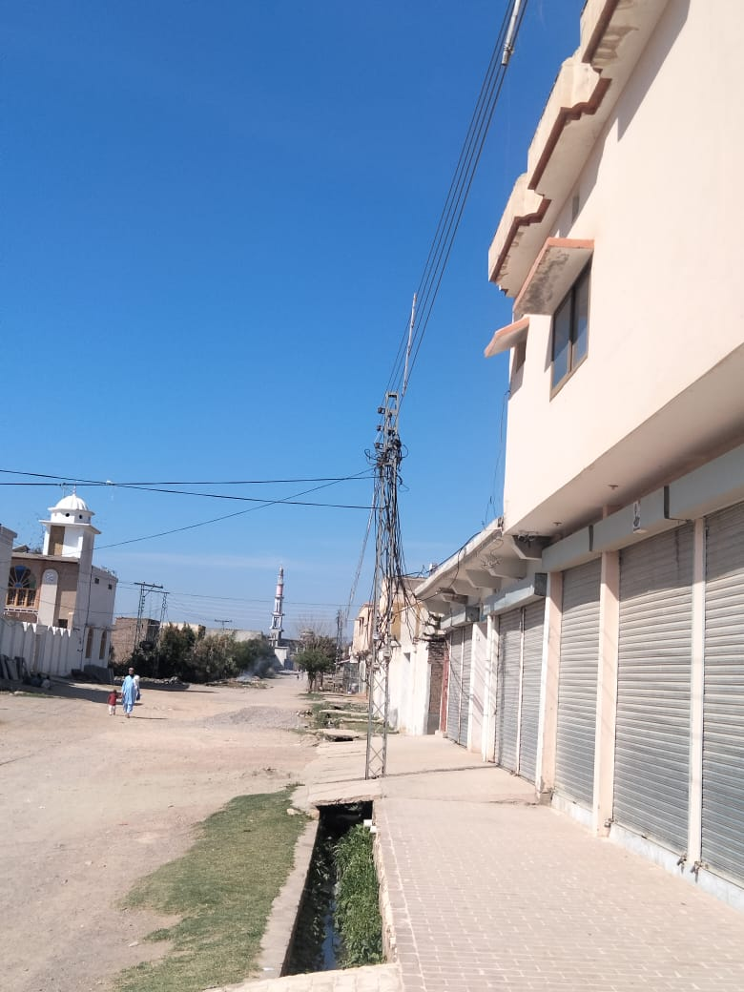
- S/Division: Kohat Urban-II
Feeder: S. Factory
The total number of consumers are 5265. The area is mainly comprised of Semi- urban residential set up The major sources of livelihood are transportation, oversees Pakistani(Gulf countries), Government and Private employment, local small business, Poultry and local breeds of cattle are also good source of income for the people of Kohat. The law and order situation is Normal (No such civil unrest activities reported )
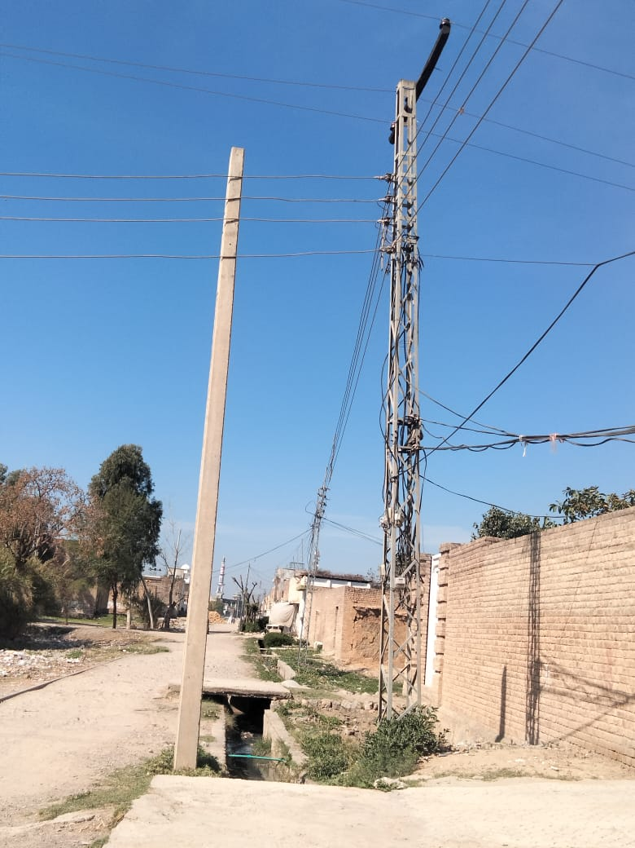
- S/Division: Kohat Urban-II
Feeder: Tappi The total number of consumers are 2844. The area is mainly comprised of Complete rural residential set up rain fed area The major sources of livelihood are transportation, oversees Pakistani(Gulf countries), Government and Private employment, local small business, Poultry and local breeds of cattle are also good source of income for the people of Kohat. The law and order situation is Normal (No such civil unrest activities reported )
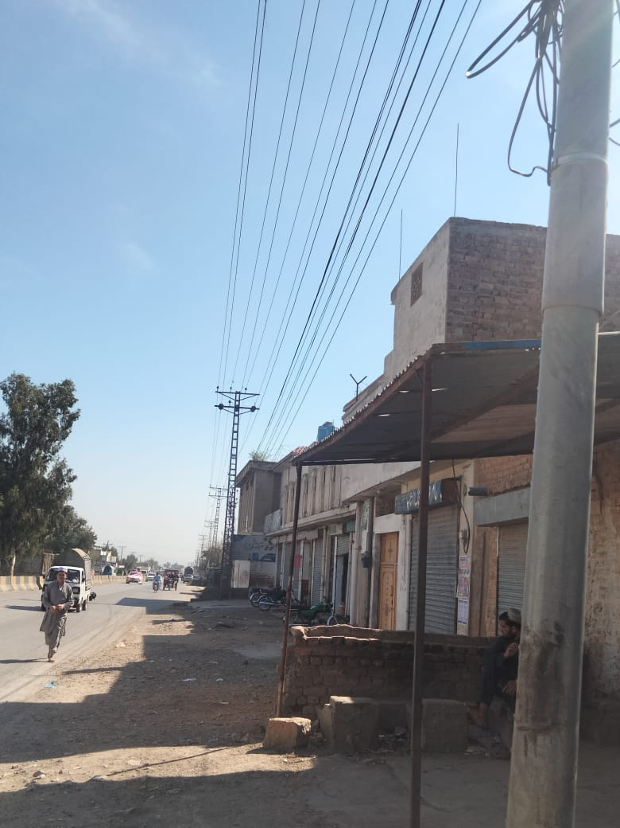
- S/Division: Kohat Urban-II
Feeder: Jarma. The total number of employees are 2385. The area is mainly comprised of Complete rural residential set up rain fed area. The major sources of livelihood are transportation, oversees Pakistani(Gulf countries), Government and Private employment, local small business, Poultry and local breeds of cattle are also good source of income for the people of Kohat. The law and order situation is Normal (No such civil unrest activities reported )
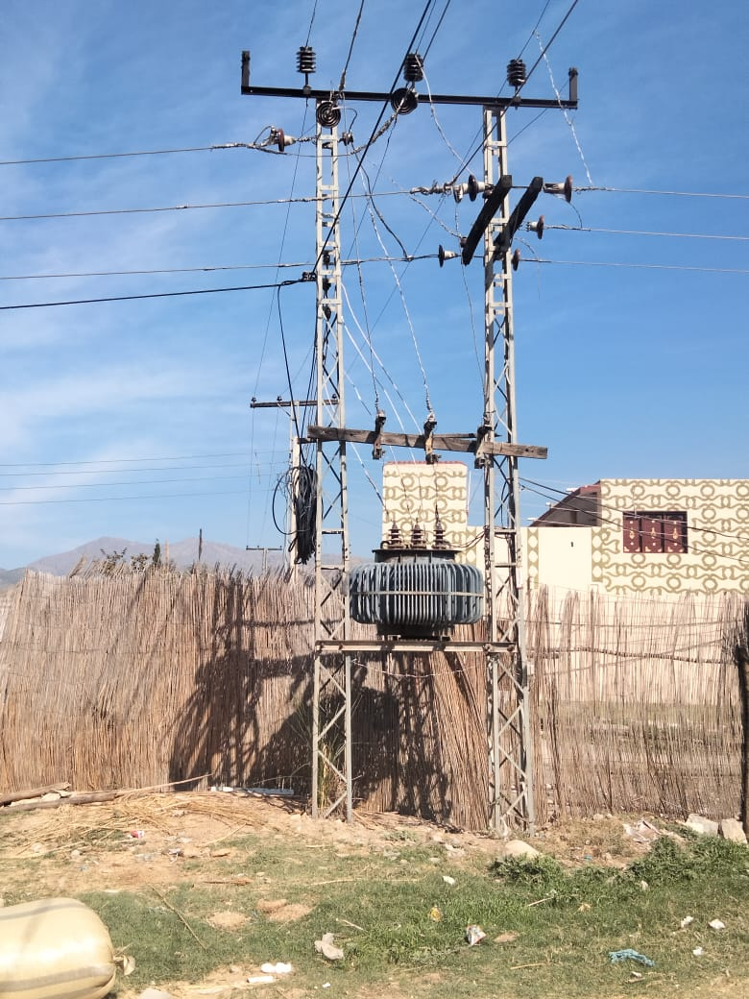

Chapter No.04
RISK ASSESMENT AND MITIGATION
The proposed 11 KV feeders for ABC Cable under EDEIP fall in the area of mild resistance from the consumers. In these areas the people don’t challenge the writ of the department, so they usually used hooks during nighttime when there is no patrolling on the live line/feeder. Planning directorate PESCO has already been completed 500 KM ABC Cabling in the worst area. the resistance from consumers was addressed through the involvement of elders and influentials of the area, also representative from local Government and District administration.
The ABC Cable has been designed with the following main features / qualities:
- It ensures safety.
- Reliability
- Aesthetics

Potential Risk |  | Mitigation Actions | Responsible | Monitoring Responsibility
Conflicts/resistance from project area community. |  | Potential conflicts between local communities and the executing agency will be resolve by involving community leaders influentials of the area and District Government. Regular consultations will be carried out with the relevant consumers and other community members. | Construction Contractor/  PIMSC;  E&S Team of PMU | E& S team PMU PESCO
Construction worker occupational health and  safety (OHS) |  | The contractor will prepare Occupational Health and Safety Management Plan (OHSMP), have it approved by PIU, and implement it during the construction works. The OHSMP will comply with the PESCO Safety Code, and other applicable codes and guidelines.  Only qualified and trained workers will be employed by the contractors.  Contractor will arrange regular OHS training for the workers.  All construction workers will ensure to execute work after obtaining proper Permit to work and use of PPE.  All workers will be provided with appropriate PPE including insulating gloves, hard hats and safety boots.  All labour laws and regulations of Pakistan like Payment of Minimum Wage, Overtime Payment, Hours of Work, Child Labor will be strictly implemented.  WB EHS Guidelines for Electricity Transmission and Distribution and General EHS Guidelines: Occupational Health and Safety will be strictly implemented.  Worker working with electrical equipment or in situations where electrocution is a risk, will be provided with insulated gloves and other relevant personal protective equipment. | Construction Contractor/  PIMSC | E& S team PMU PESCO
Community health and safety | The OHSMP mentioned earlier will include precautions and measures for safety of communities  Barricading of work areas will be carried out where appropriate/possible.  Community awareness will be raised for the safety risks associated with the works and how to avoid the risks. Safety signs will be installed where practical.  The Contractor’s workers shall follow the code of conduct to avoid and minimise disruption and harm to community.  The Contractor shall provide details of how to make a complaint in a prominent place. |  | Construction Contractor/  PIMSC | E& S team PMU PESCO
Complaints from the neighbours and local community | Proper Full fledge GRM will be implemented at each Project site, Maximum efforts will be made to avert any issue to happen. In case of a complaint proper mechanism will be established at each project site to register complaints and its solution well in time through GRC. |  | Construction Contractor/  PIMSC | E& S team PMU PESCO
Privacy of women/local population | The contractor will prepare a proper code of conduct for the contractor staff in order to ensure the Privacy of women/local population |  | Construction Contractor/  PIMSC | E& S team PMU PESCO
Gender issues including SEA/SH risks | The GRM will be made transparent and Gender-responsive to cover Gender issues including SEA/SH risks |  | Construction Contractor/  PIMSC | E& S team PMU PESCO
Waste disposal | A proper waste disposal mechanism will be established for the collection storage and final appropriate disposal of waste. |  | Construction Contractor/  PIMSC | E& S team PMU PESCO
Traffic management | Traffic management plans shall be used to manage any heavy traffic, large vehicles or other potential risks to road users and the community. |  | Construction Contractor/  PIMSC | E& S team PMU PESCO
Labor issues | LMP will be followed. |  | Contractors

Chapter No.05
Public Consultation

Public consultation
In the analogy of the same the following consultations were carried out as an ongoing process of consultation to get their views and comments about the ABC Cabling in the area and to consider their inputs, suggestion and recommendation in the proposed package.

Stakeholder | Points of Discussion and Concerns  Raised | Response from Disco | Consultation  Date, and DISCO  Responsible
- Urmer Feeder  SUB Division  Name: Rehman Baba  - Mirza dher and  - Sherpao Feeders,  - Umerzai  - Akhune Abad  Feeder,  - Rasheed  Garhi  - Tangi Mira and  - Abazai Feeders | Regarding the safety of staff and general public, the respondents said that PPEs are provided to them, they also added that before commencement of work on lines the influentials of the area are taken into confidence to avoid any public nuisance.  Feedback from PESCO Consumers (General public):  During consultation with the general public particularly, the paying consumers highly appreciated the proposed scheme as they are facing more than 18 hours load shedding in the area. They also hoped that it also addresses the issues of overbilling due to hooks and electricity theft. As the consultation took place with diversified group of peoples, so many of them especially commercial consumer added that bare conductor had caused short circuit in the markets and burned their valuable assets and shops and affected their livelihood. | The PESCO Staff were specifically asked about ABC cables and listed the following benefits of using ABC cables:  - ABC cable will eliminate fatal and non-fatal incidents  - it will also eliminate the damages to distribution transformers caused by hooks,  - The insulated cable  will restore aesthetic beauty of the area.  - , It will address issues of short circuits.  The cable on one hand will reduce the maintenance cost for PESCO and on other hand will eliminate cost on general public for shifting of these lines during construction of their houses etc.  • Further, during raids when the culprits are caught red handed, it led to a conflict due to stigmatization in society, so the proposed project will strengthen the weakened ties between PESCO and general public. | 28/01.2021- PESCO  27/01/2021- PESCO  28/01/2021- PESCO  27/01/2021- PESCO
- Baghbanan (Kichori) Feeder (Rehman Baba Sub-Divivsion | During consultation with general public the following questions were asked,  - Whether during installation of ABC did you faced any unrest from PESCO.  - Whether your social and cultural norms are affected.  - Whether your trees crops drains or any assets are affected.  - Any conflict between the parties i.e. general public and PESCO happened.  - Any OHS issue (fatal non-fatal reported during the implementation or installation of the ABC cable.  - Any other issue or comment.  Response of the Public:  - The General Public added that no such unrest issue happened during installation of ABC Cable.  - Prior to the commencement of installation work our elders were taken on board for the supply and storage of ABC consignment to our village social activist are involved the project to avoid any untoward situation.  - The locals argued that, as the line passing through main road and streets therefore no tree trimming, and crops damages reported.  - The locals requested for establishment of complaint office for proper patrolling and attaining faults. | PESCO team assure the locals that your request for the establishment of complaint office will be forwarded to the quarter concerned for implementation, further PESCO team clarified the purpose of the visit that, PESCO is going extend the same project activities to the nearby villages the aim of this consultation is to get your feedback concerns if any to address in the future endeavors. | 03.03.2023

Consultation is to be carried out before the Commencement of Project work at the site.
Stakeholders | Mode of Consultation | Responsibility
Contractors | Face-to-face consultation at each project site | E&S team PMU, Contractor, Consultant
Consultant | Face-to-face consultation at each project site | E&S team PMU, Contractor, Consultant
Community | Face-to-face consultation at each project site | E&S team PMU, Contractor, Consultant
Contractor work Gangue | Face-to-face consultation at each project site | E&S team PMU, Contractor, Consultant

Consultation is to be carried out during the ABC Work of the Project at the site.

Stakeholders | Mode of Consultation | Responsibility
Contractors | Face-to-face consultation at each project site | E&S team PMU, Contractor, Consultant
Consultant | Face-to-face consultation at each project site | E&S team PMU, Contractor, Consultant
Community | Face-to-face consultation at each project site | E&S team PMU, Contractor, Consultant
Contractor work Gangue | Face-to-face consultation at each project site | E&S team PMU, Contractor, Consultant

Zhang, Fan. 2019. In the Dark: How Much Do Power Sector Distortions Cost South Asia? South Asia Development Forum. Washington, DC: World Bank. https://www.doi.org/10.1596/978-1-4648-1154-8.

